

**EPOSH BOOKING HOTEL**

**Mentor:** [Nguyễn Trung Hiếu (FE FPTU CT)](mailto:hieunt239@fpt.edu.vn)

**Group 1:**

|  |  |
| --- | --- |
| **Member Name** | **MSSV** |
| **Trần Quốc Bảo (Leader)** | **CE160365** |
| Nguyễn Tiến Đạt | CE150672 |
| Nguyễn Thanh Phong | CE160482 |
| Nguyễn Văn Hiếu | CE150343 |
| Đoàn Minh Hiếu | CE160738 |

**Table of contents:**

**I. Introduction 2**

**II. Project Structure 3**

1. Back-end 3

1.1. ASP.NET Core Web API: 3

1.2. We use this because: 3

2. Front-end 4

2.1. ReactJS: 4

2.2. TypeScript: 4

2.3. Benefits of combining ReactJS with TypeScript: 4

**III. Use Case 5**

**IV. Entity Relationship Diagram 7**

**V. Sequence Diagram 8**

1. Authentication 8

2. Customer 13

3. Admin 17

**VI. Document and source code change management methods 22**

**VII. UI Design 23**

1. Authentication 23

2. Customer 25

3. Admin 39

**VIII. Task assignment table 54**

# **Introduction**

Welcome to EPOSH HOTEL - where you find comfort and elegance in every journey!

EPOSH HOTEL is the ideal destination for those seeking luxury, convenience, and professional service. With a prime location situated on convenient transportation routes, we provide easy access to famous tourist attractions, entertainment areas, and shopping centers.

We take pride in our modern facilities, spacious rooms, and fully equipped amenities to provide the finest staying experience for our guests. At EPOSH HOTEL, it's not just a place to stay but also a place to relax, enjoy privacy, and indulge in premium services.

With our convenient online booking system, booking a room at EPOSH HOTEL has never been easier. Guests can ensure their accommodation for their trip with just a few simple steps on their mobile phones or computers without any hassle.

Let EPOSH HOTEL be your ideal destination for your vacation, where comfort, convenience, and dedicated service will satisfy even the most discerning guests. We look forward to welcoming you here!

# **Project Structure**

## Back-end

### **ASP.NET Core Web API:**

* As a powerful technology for building flexible and efficient API services, we will use ASP.NET Core Web API to develop the EPOSH HOTEL management system in this project. This project is organized according to the 3-tier architecture to ensure clear separation and organization of logic, including:
* Data Access Layer (DAL): This part is responsible for handling the process of connecting to the database.
* Business Object Layer (BOL): This is where business logic and business processing rules reside. BOL will include classes representing objects in the system such as Room, Customer, Reservation, etc.
* Web API Layer: This is where the system's service-handling APIs are stored, where requests from clients will be processed. The Web API will provide endpoints to interact with the resources of the information system via HTTP, such as booking rooms, retrieving room information, updating customer information, etc. We will use ASP.NET Core to develop controllers and actions to handle these requests.

### **We use this because:**

* High separation of concerns: The 3-tier model clearly separates different layers of logic such as the data access layer, business logic layer, and user interface layer. This helps in easy code management, improves code reusability, and facilitates the development process.
* Easy maintenance and scalability: With the separation of concerns, maintenance and system scalability will become easier. Each layer has its own specific objectives and can be modified without affecting other parts of the system.
* Flexibility: The 3-tier model allows for changing a part of the system without needing to change the entire system. This makes adapting to new requirements or changes in requirements easier.
* Code reusability: Classes are divided into small independent parts to enhance code reusability. For example, database connection functionality only needs to be declared once in the data access layer and can be reused throughout the application.
* Consistency and readability: Clear division between the classes makes the source code more readable and understandable. This increases the consistency of the source code and helps rationalize it in large projects.

## Front-end

### **ReactJS:**

* We use ReactJS as the primary front-end library to build the user interface of EPOSH Booking.
* ReactJS allows us to divide the application into components, from small components like buttons and forms to large components like the main page and room detail page.
* Features of ReactJS such as Virtual DOM help improve the performance of applications by efficiently updating the user interface.

### **TypeScript:**

* TypeScript is used to write the source code of EPOSH Booking.
* TypeScript is a superset of JavaScript, allowing us to define data types for variables, parameters, and return values of functions.
* Using TypeScript helps minimize potential data type errors during development and provides source code that is easier to read and maintain.

### **Benefits of combining ReactJS with TypeScript:**

* Static type checking: TypeScript allows us to detect data type errors and logic errors at compile time, helping to minimize errors that occur during application execution.
* Integrates well with development tools: TypeScript is well-supported by source code compilers like Babel and Webpack, as well as popular programming tools like Visual Studio Code, enhancing the productivity of the development team.
* Enhancing security: Using TypeScript helps us build more secure source code by clearly defining data types and preventing common errors such as unsafe data handling.

# **Use Case**

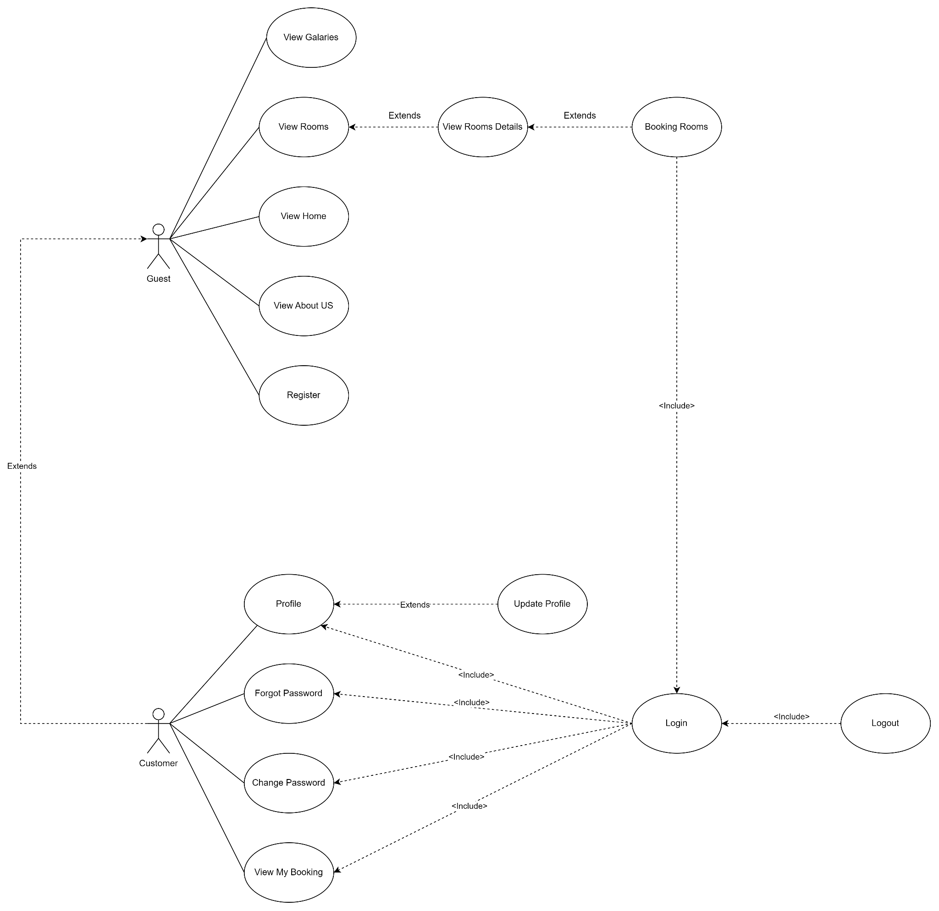

**Figure 1:** Guest & Customer Use Case

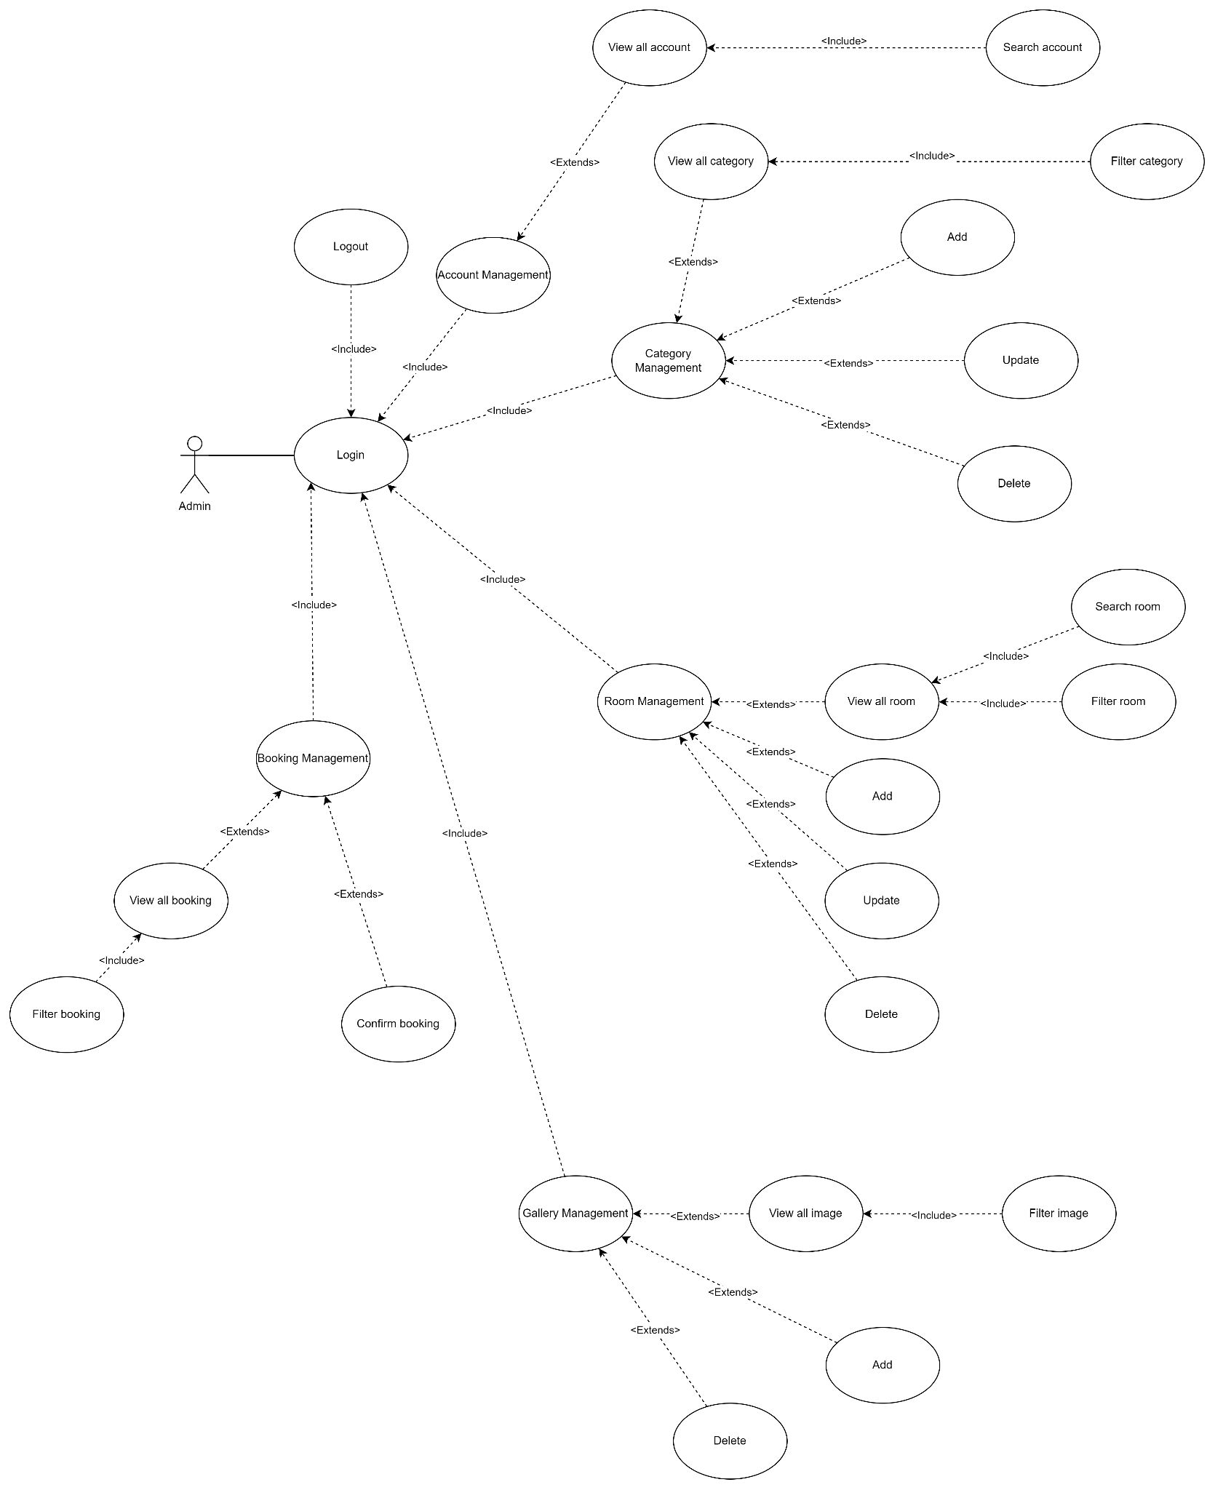

**Figure 2:** Admin Use Case

# **Entity Relationship Diagram**

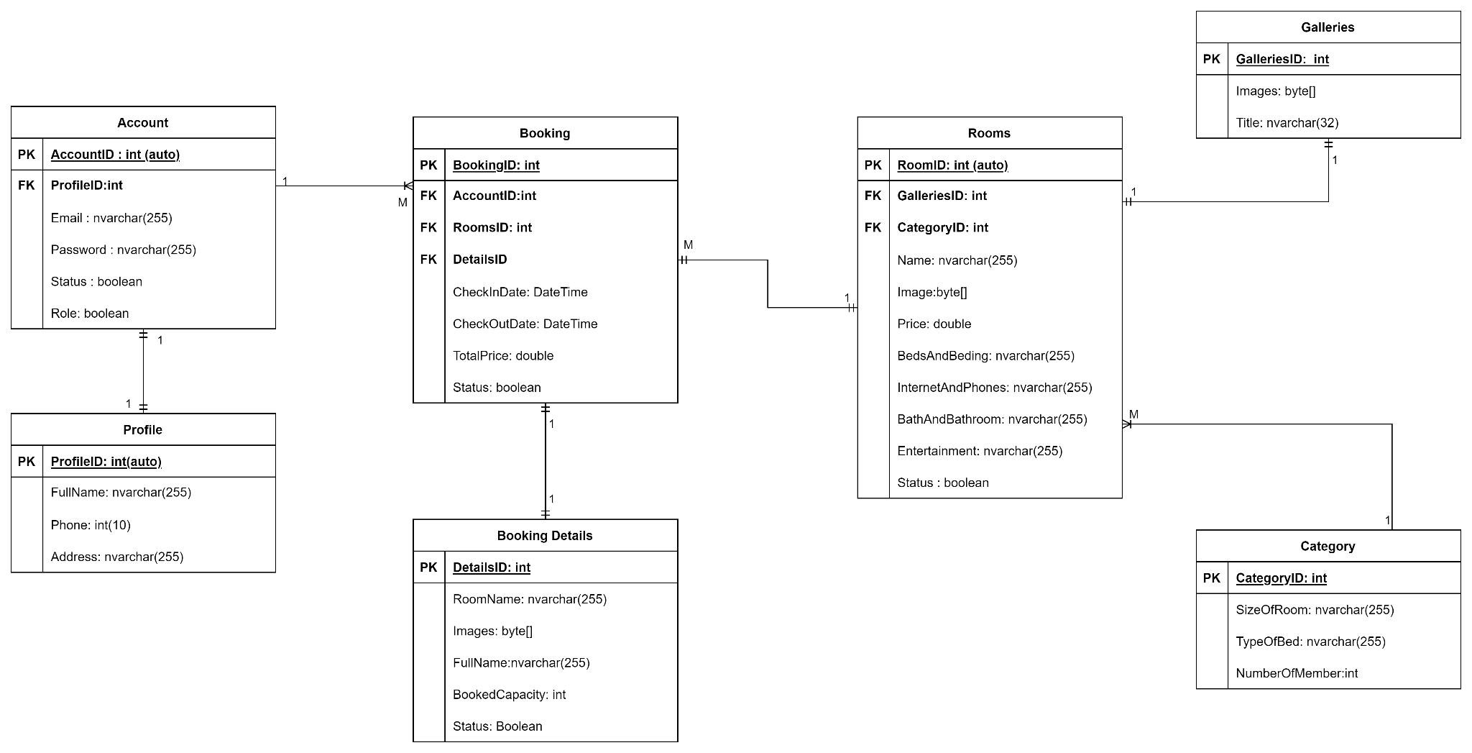

**Figure 3:** ERD

# **Sequence Diagram**

## Authentication

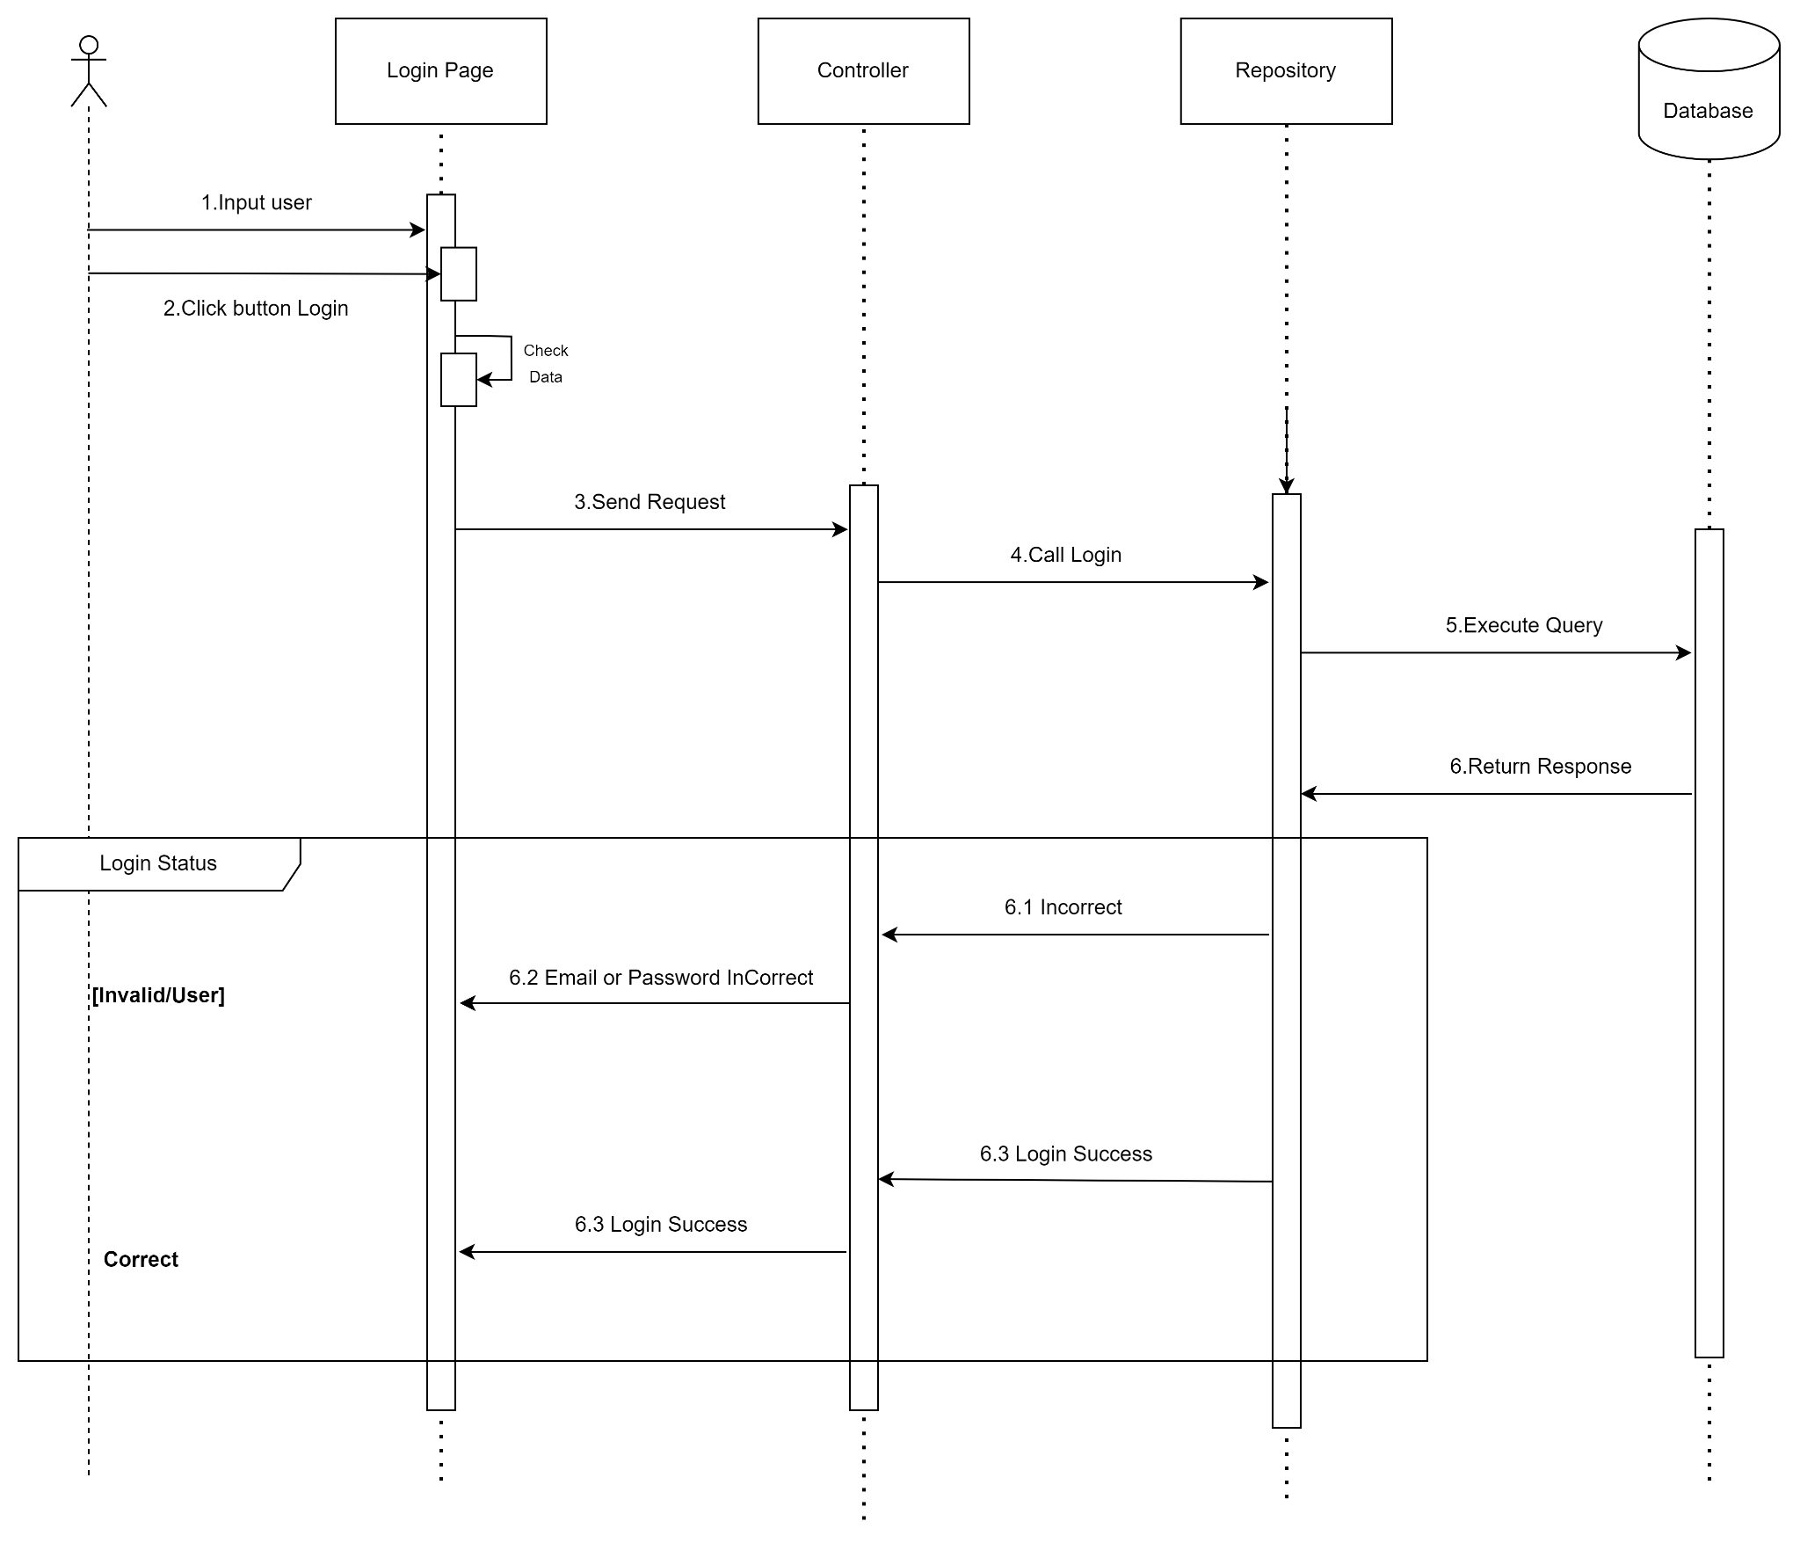

**Figure 1:** Login

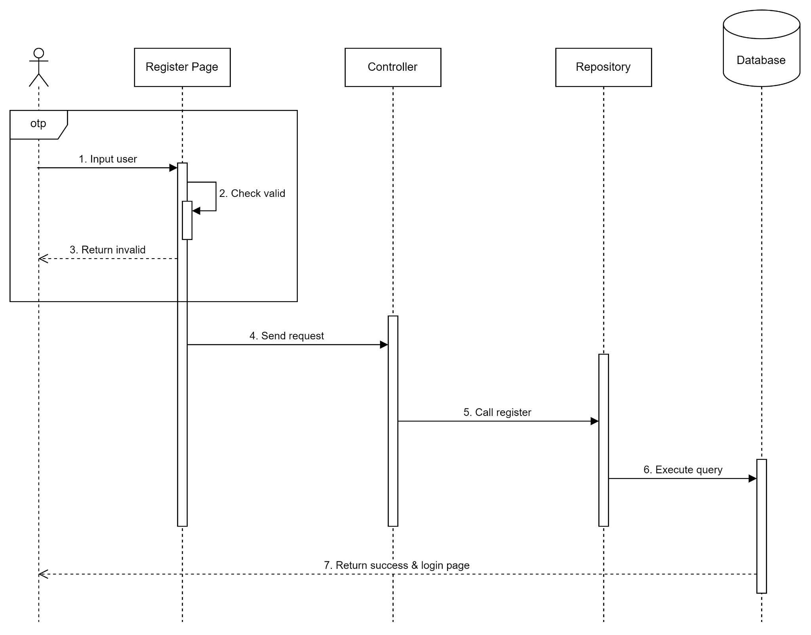

**Figure 2:** Register

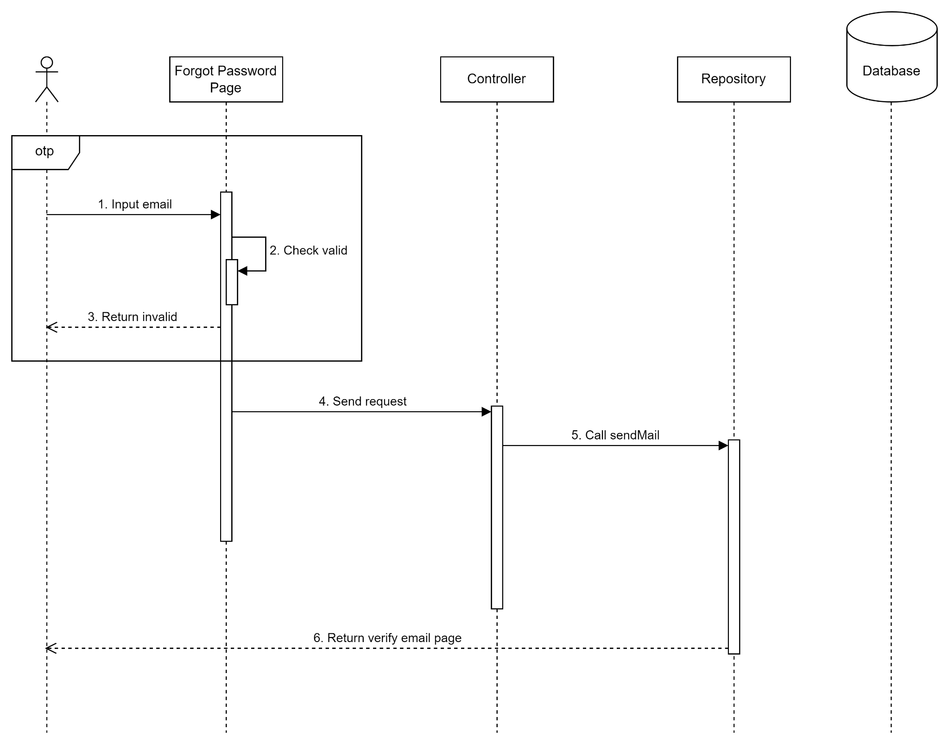

**Figure 3.1:** Forgot Password - Send Mail

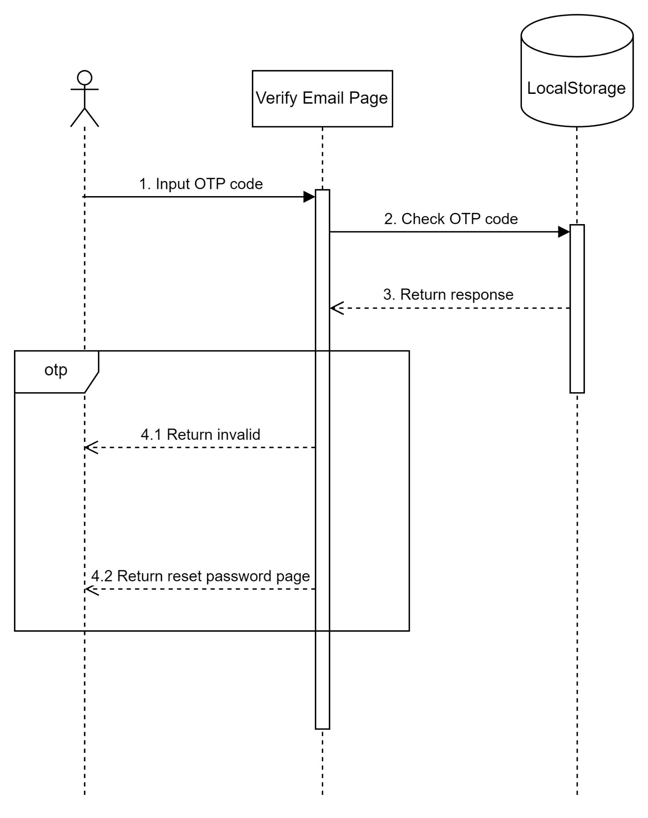

**Figure 3.2:** Forgot Password - Verify Email

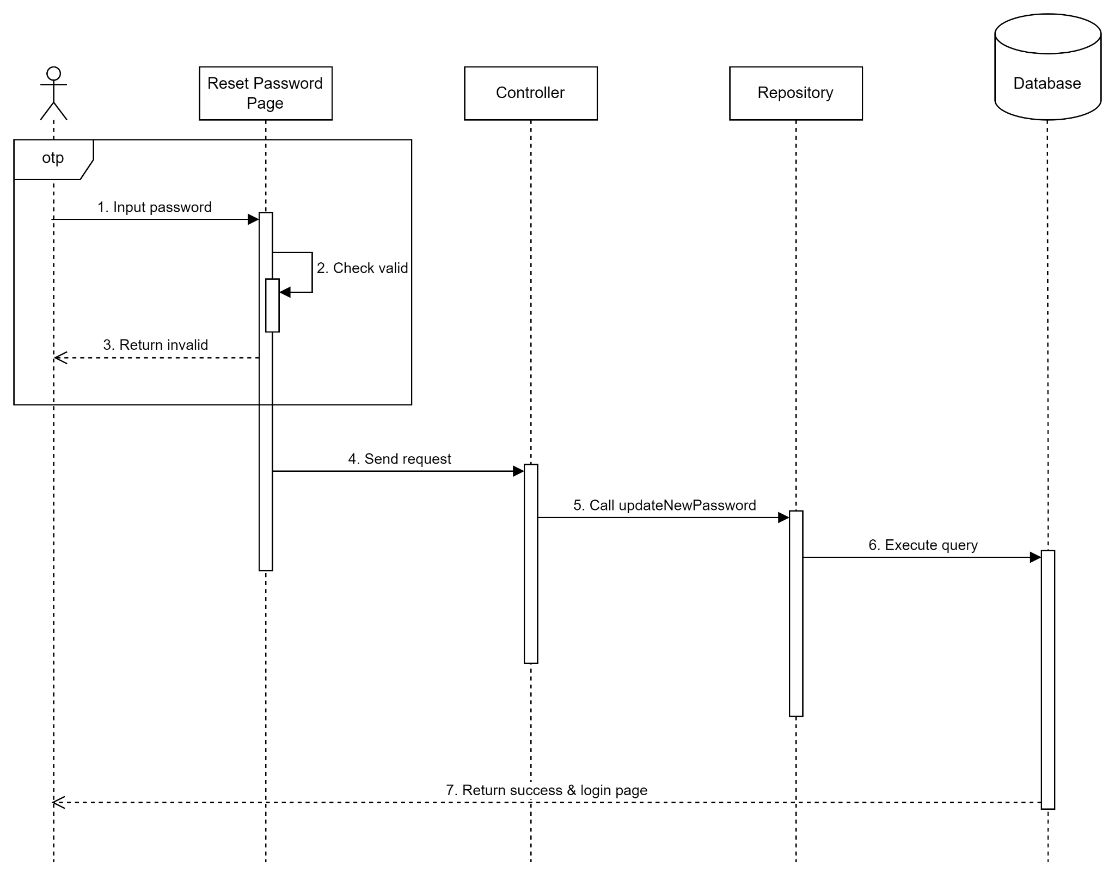

**Figure 3.3:** Forgot Password - Reset Password

## Customer

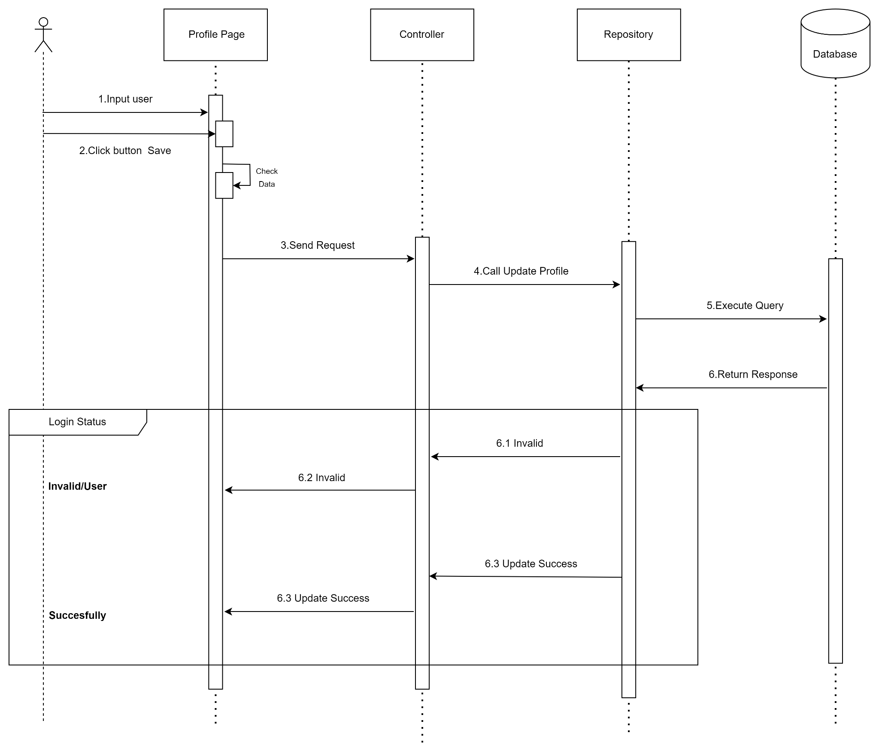

**Figure 1:** Update Profile

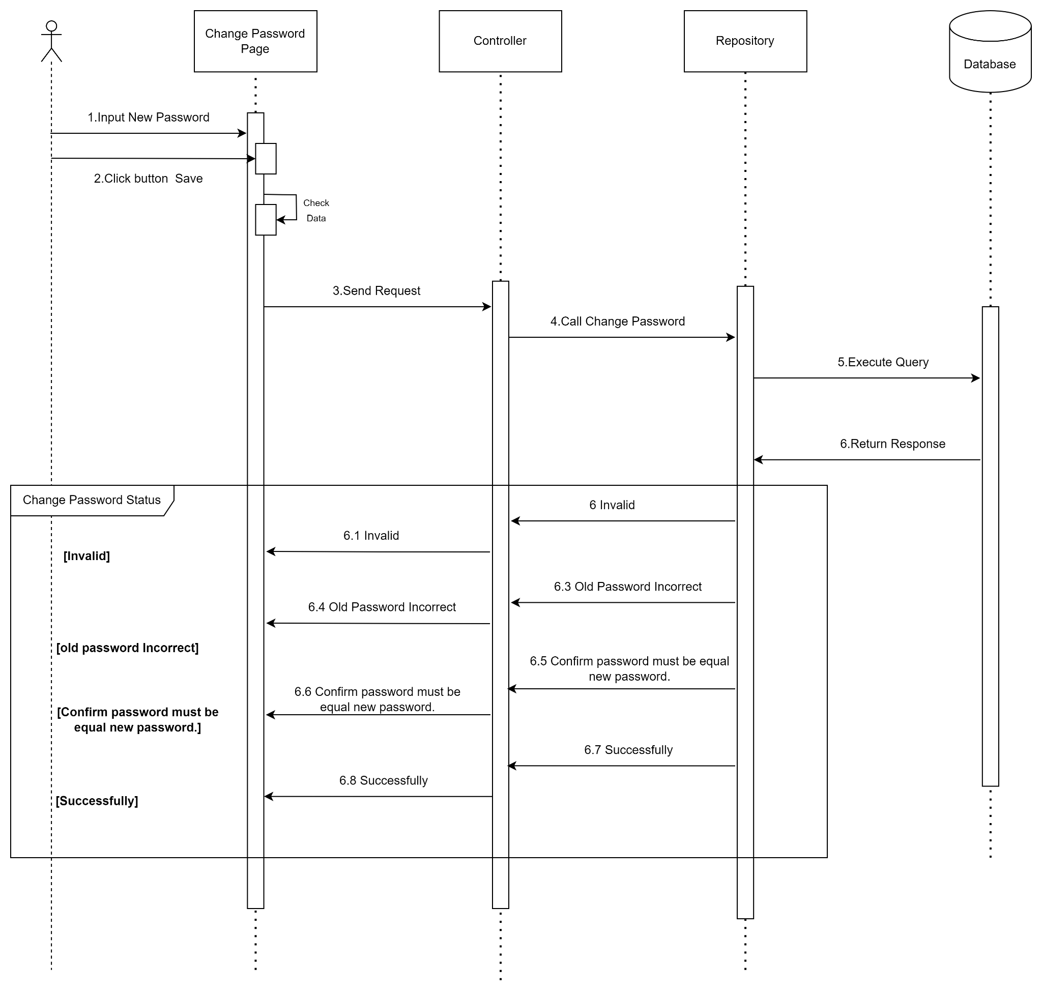

**Figure 2:** Change Password

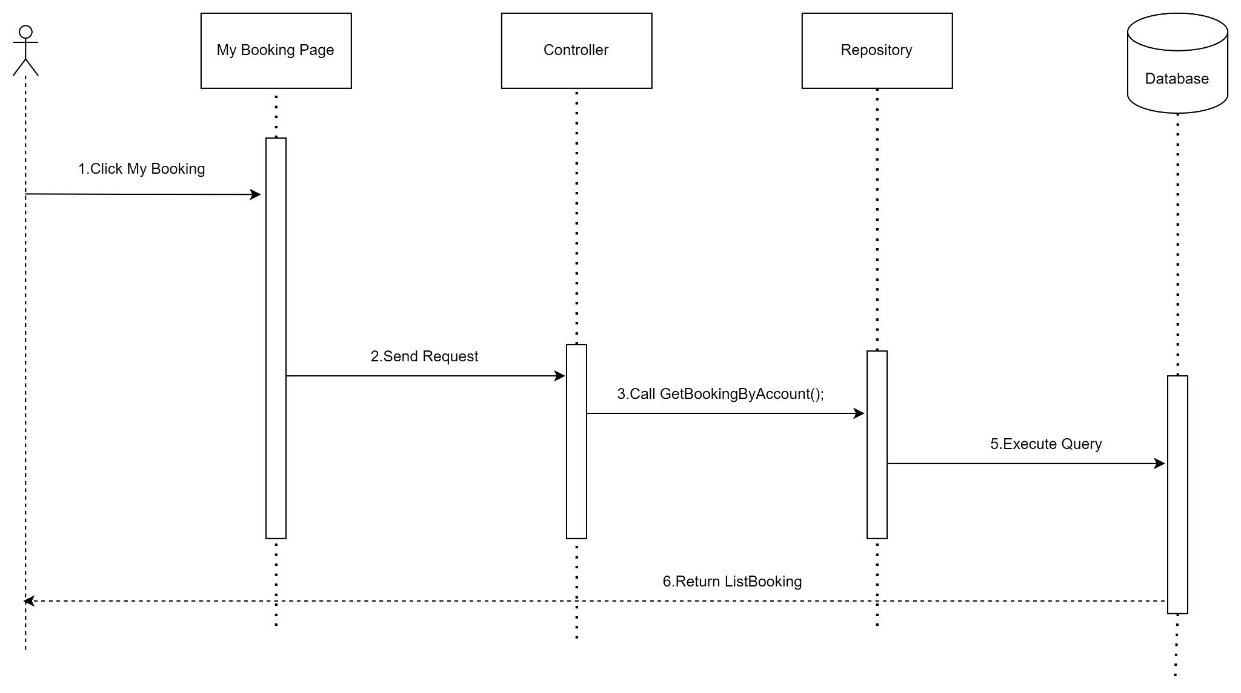

**Figure 3:** View History Booking

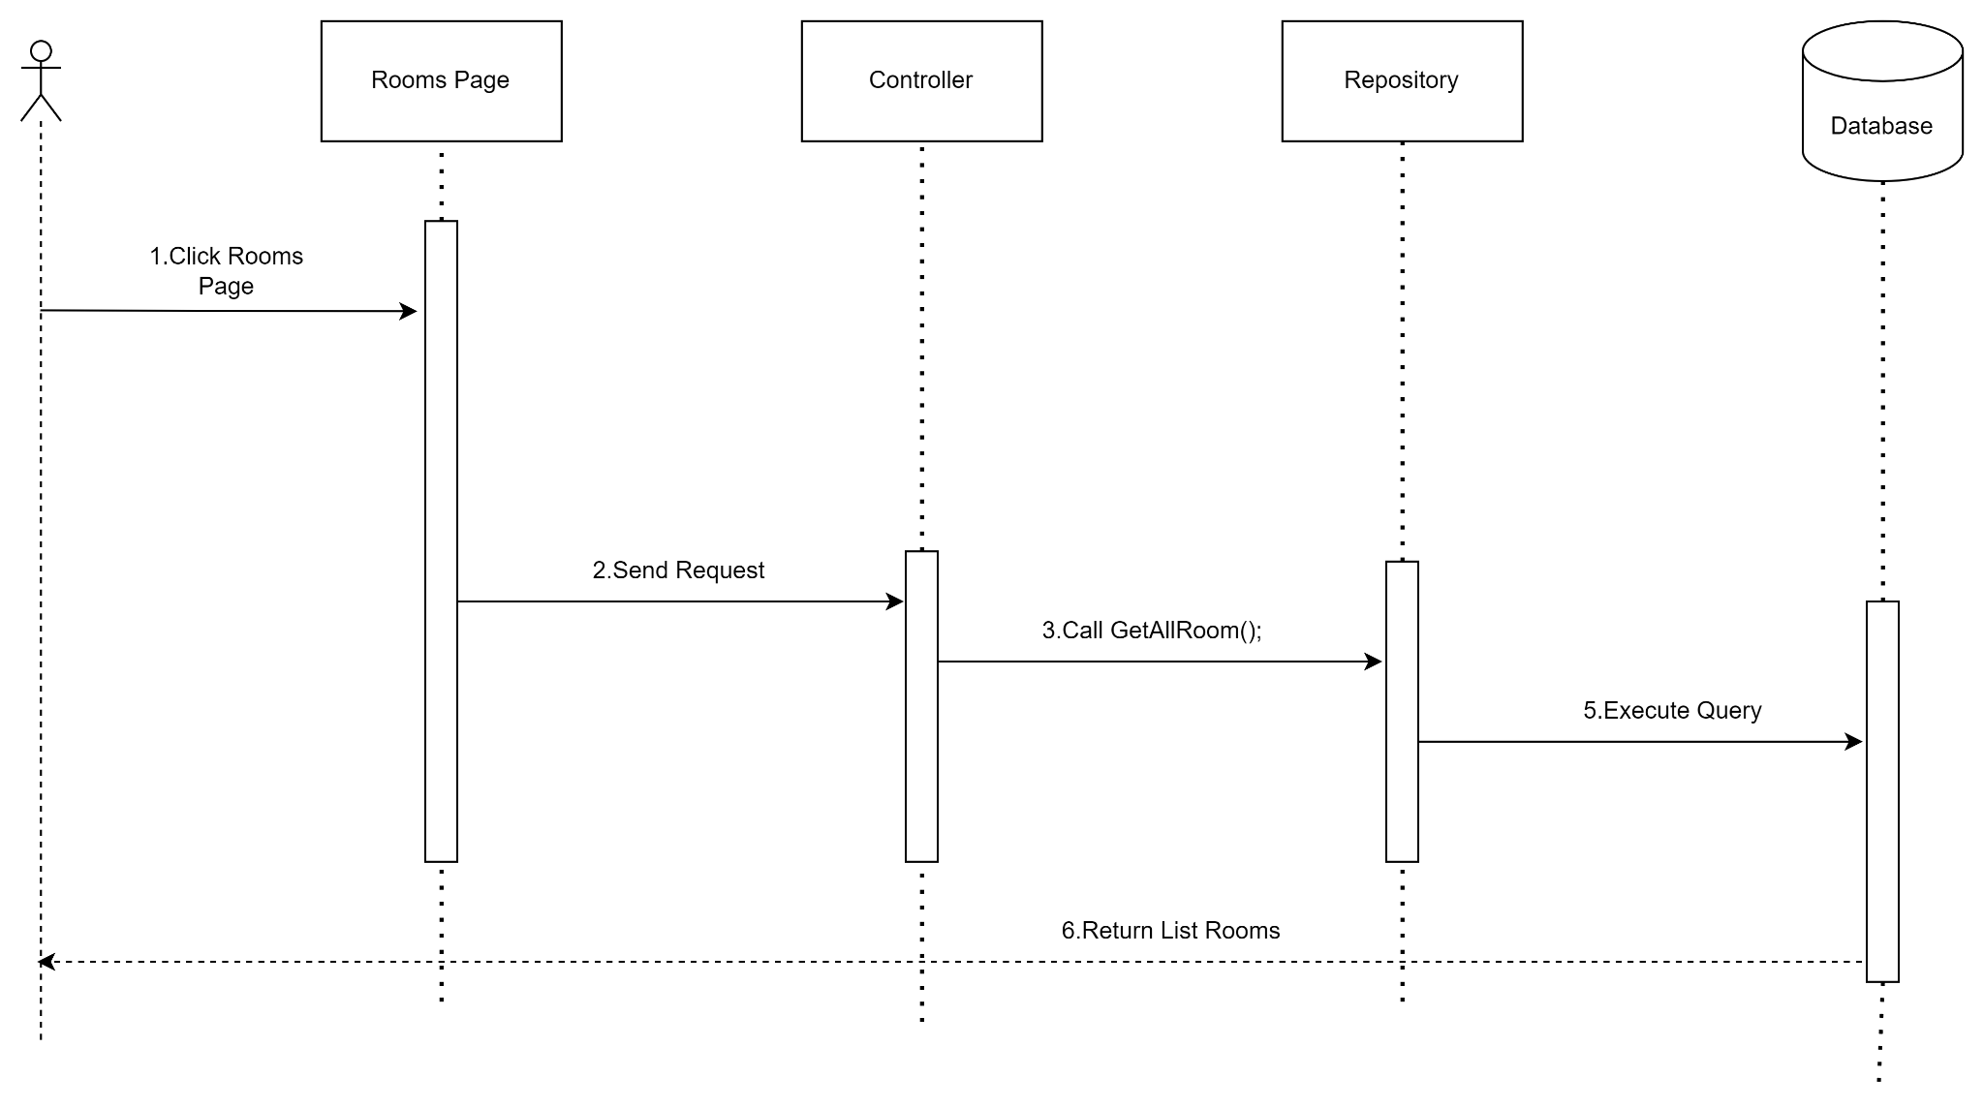

**Figure 4:** View List Rooms

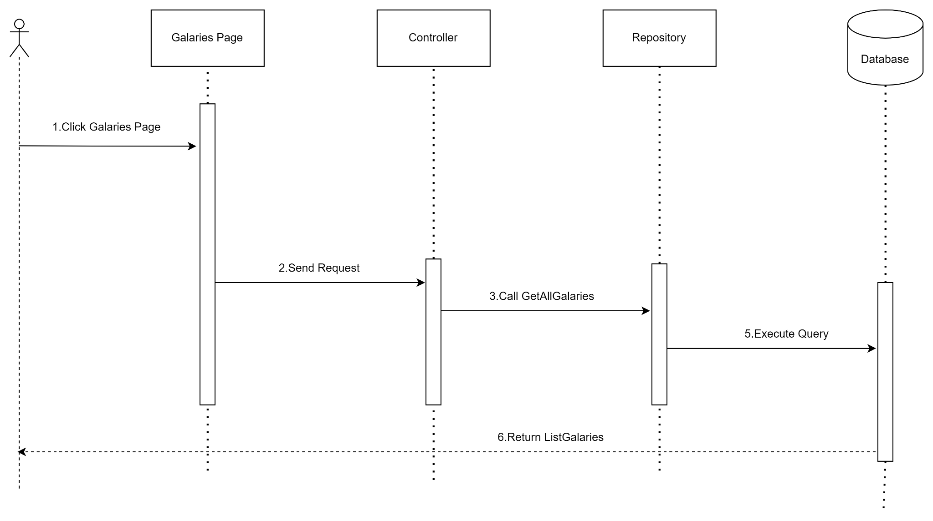

**Figure 5:** View List Images

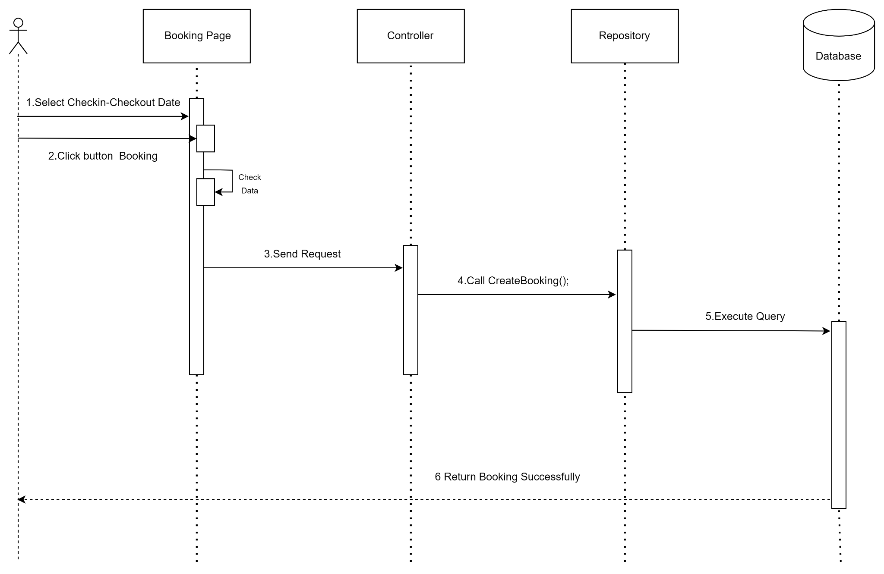

**Figure 6:** Create Booking

## Admin

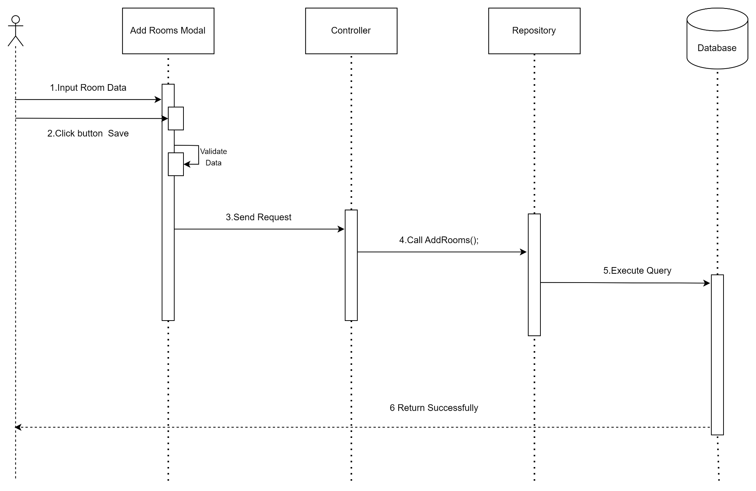

**Figure 1:** Add room

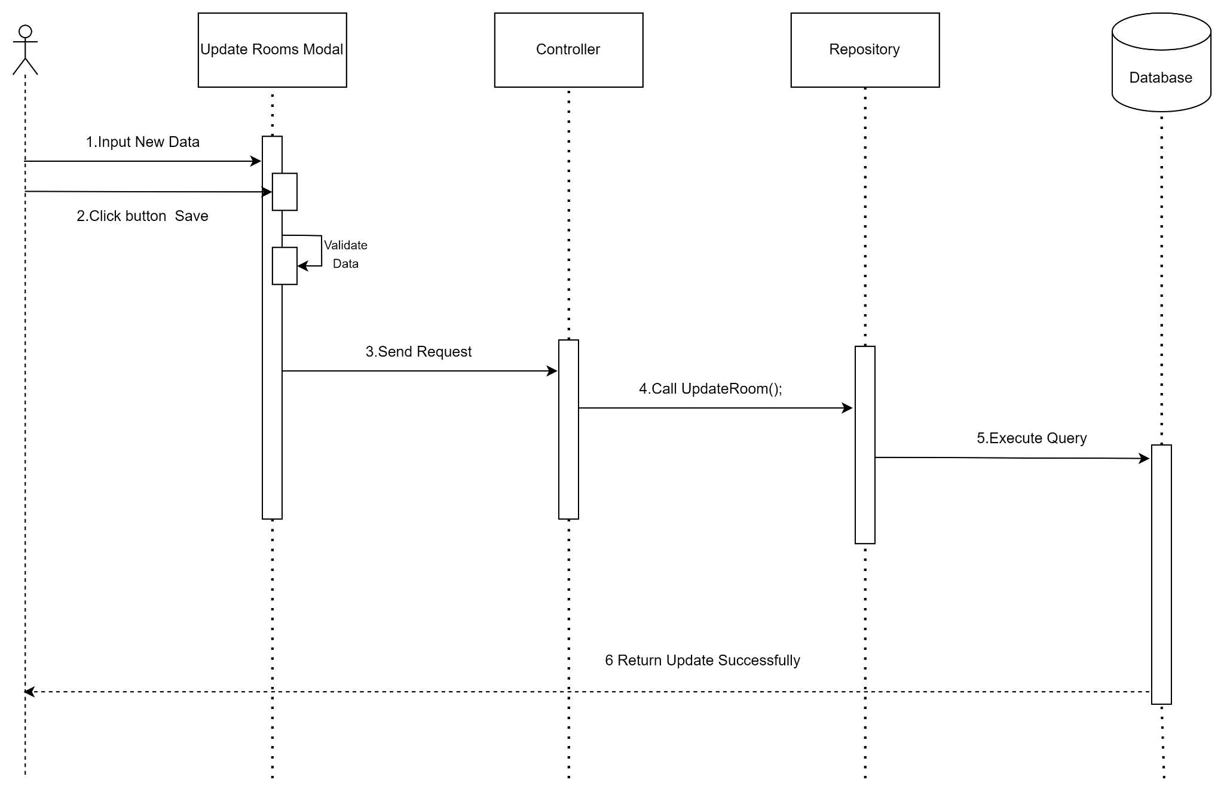

**Figure 2:** Update room

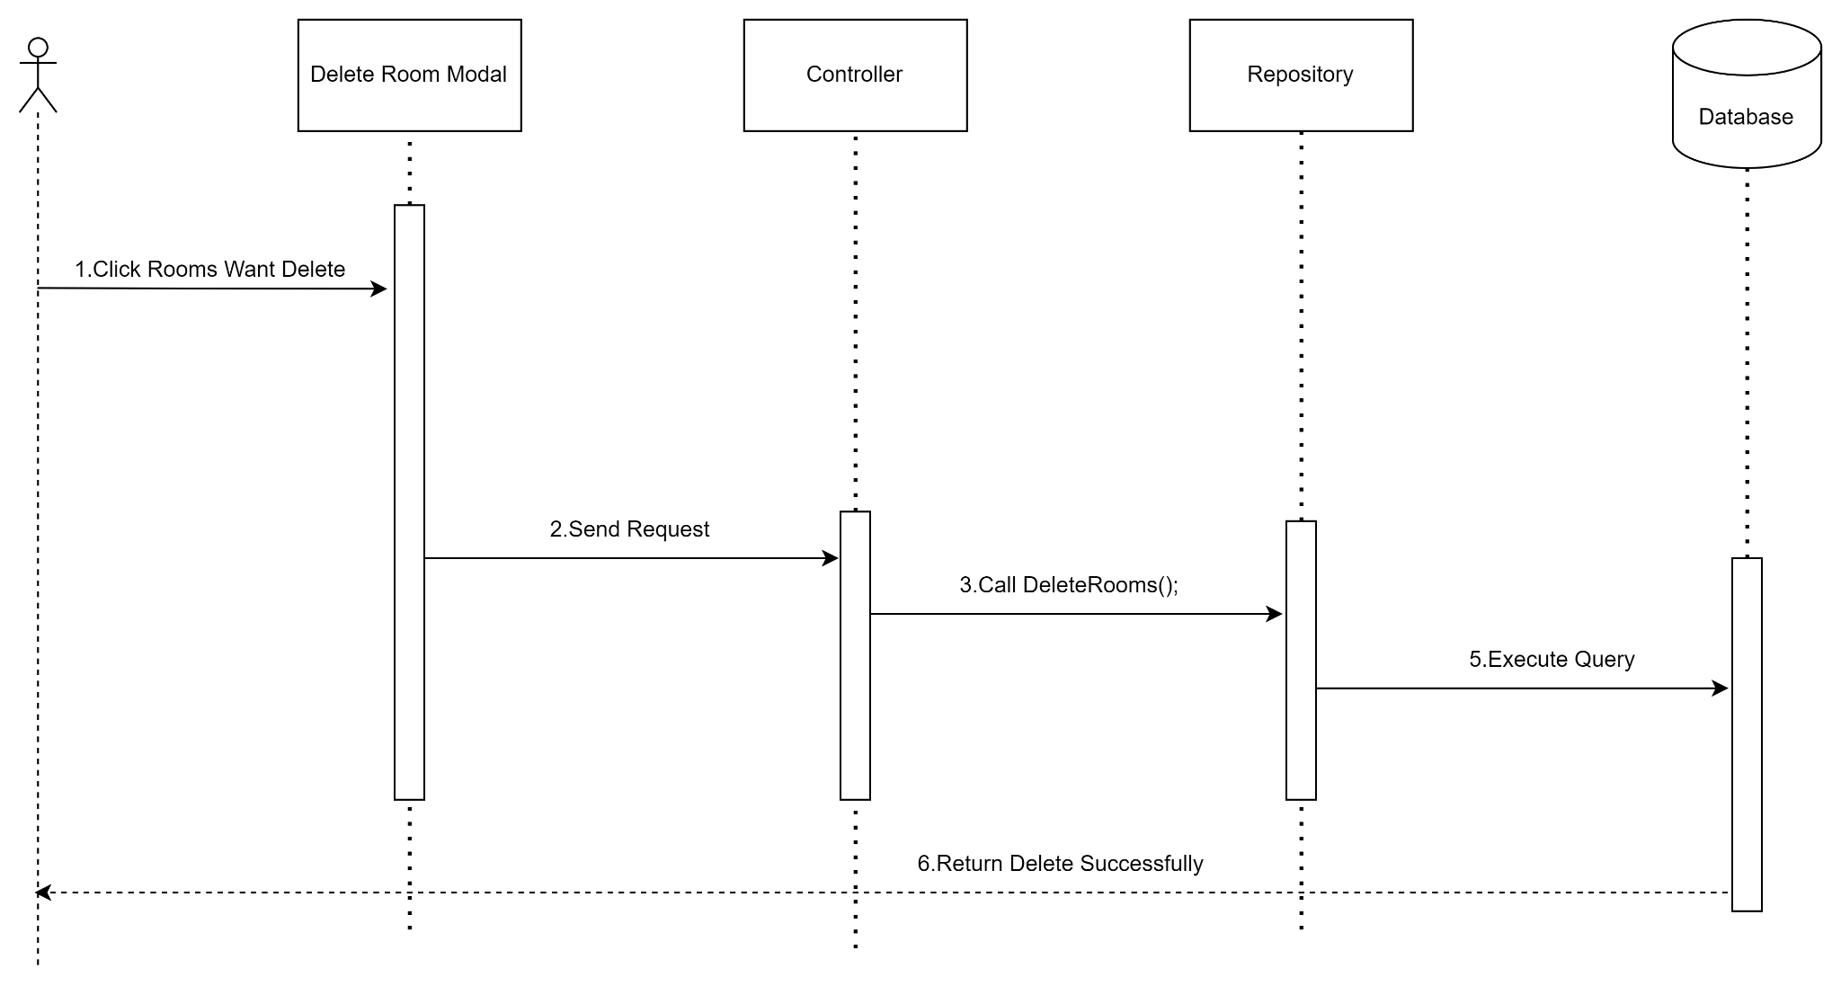

**Figure 3:** Delete room

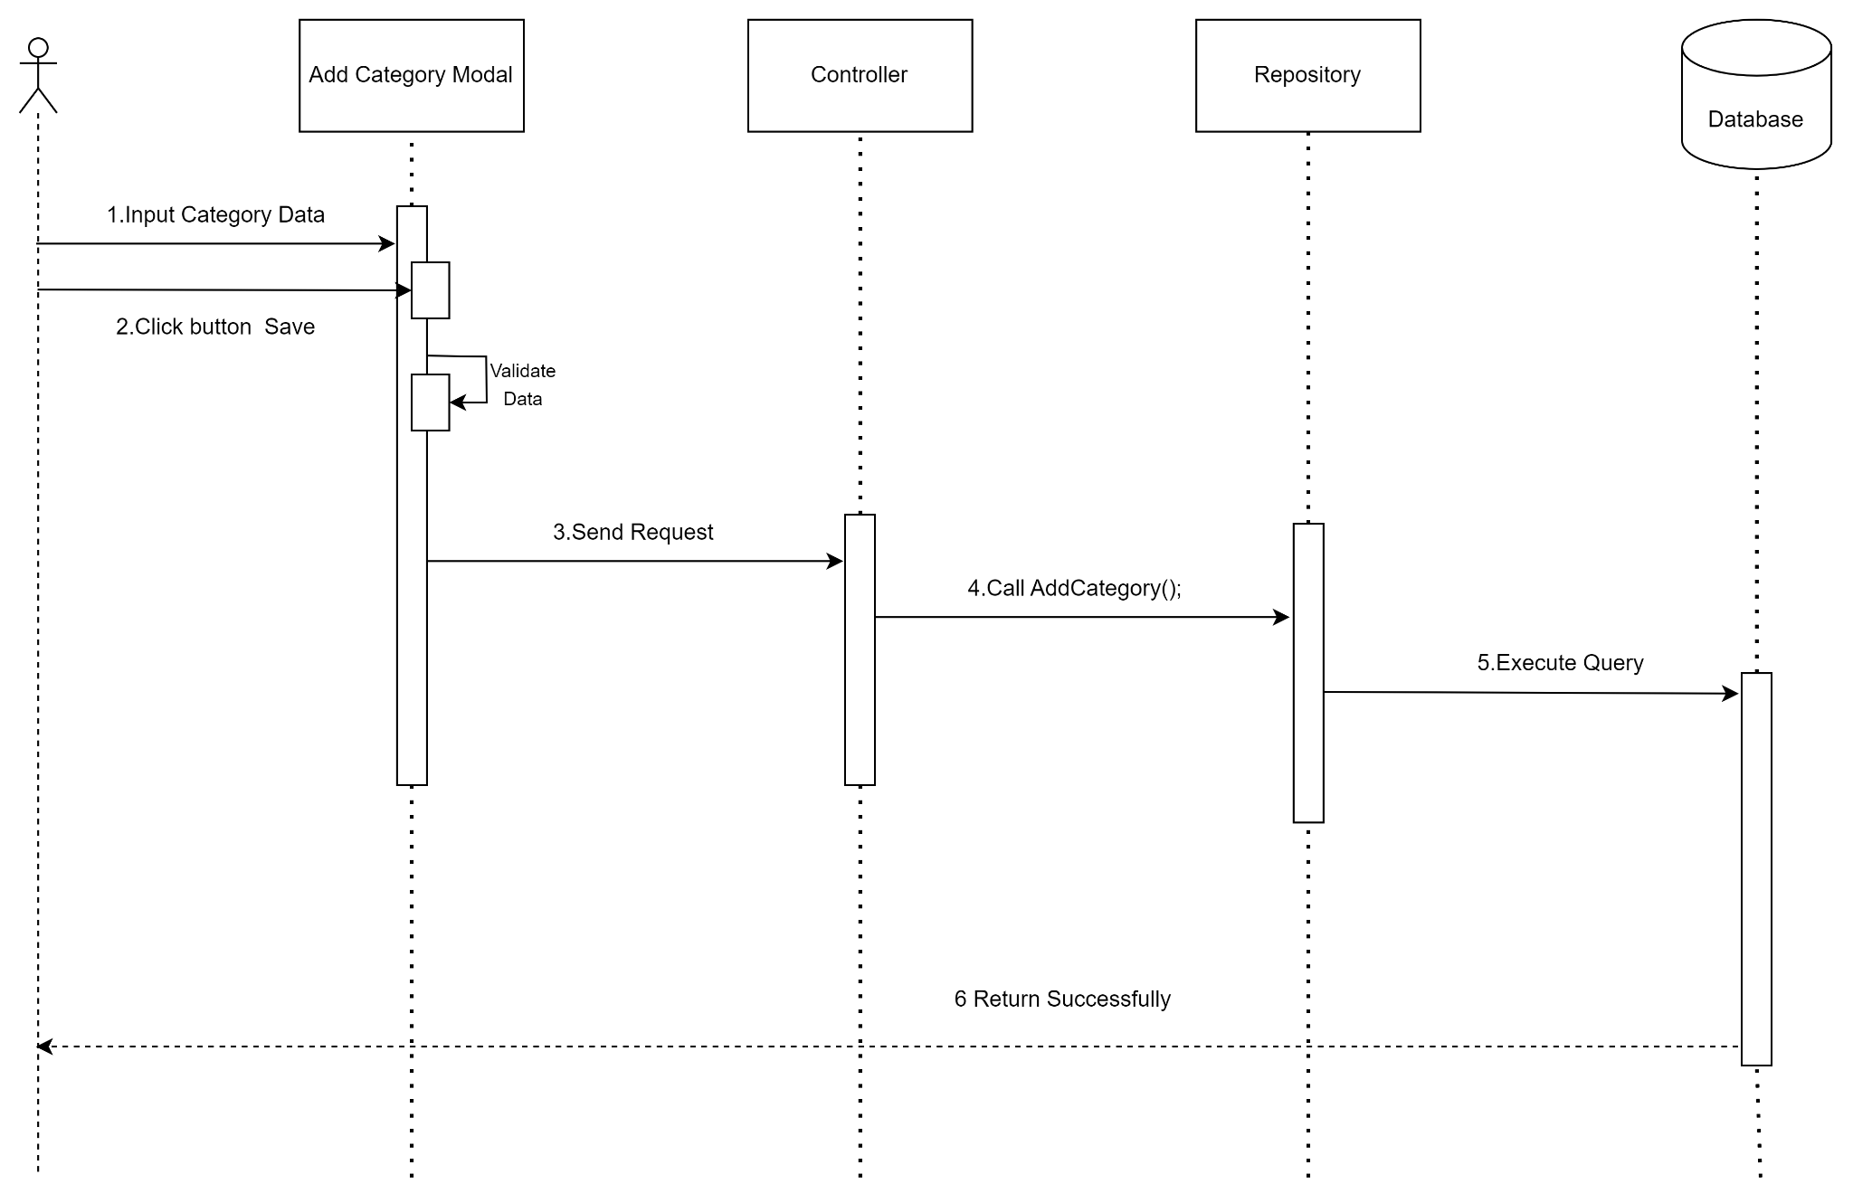

**Figure 4:** Add category

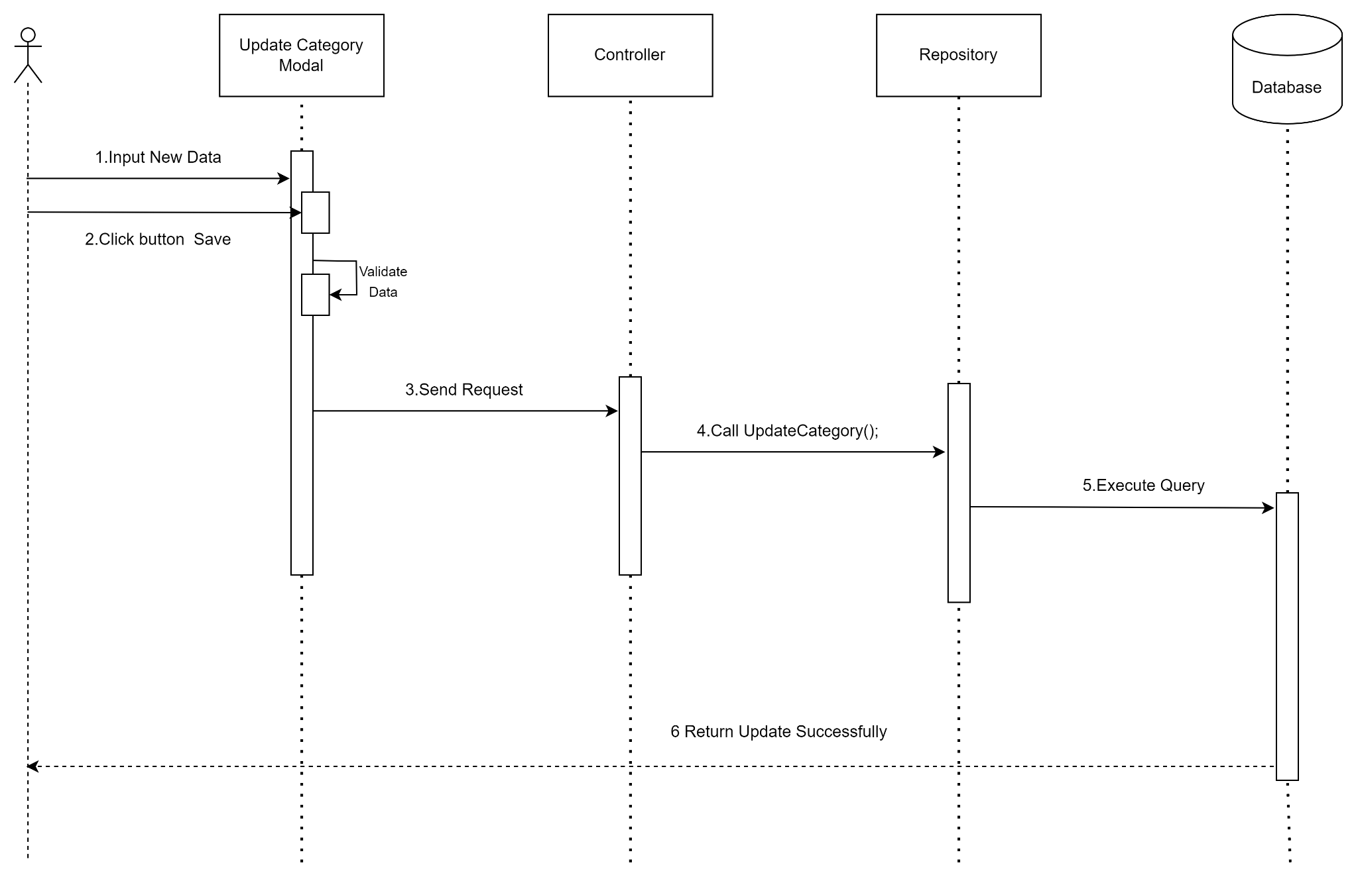

**Figure 5:** Update category

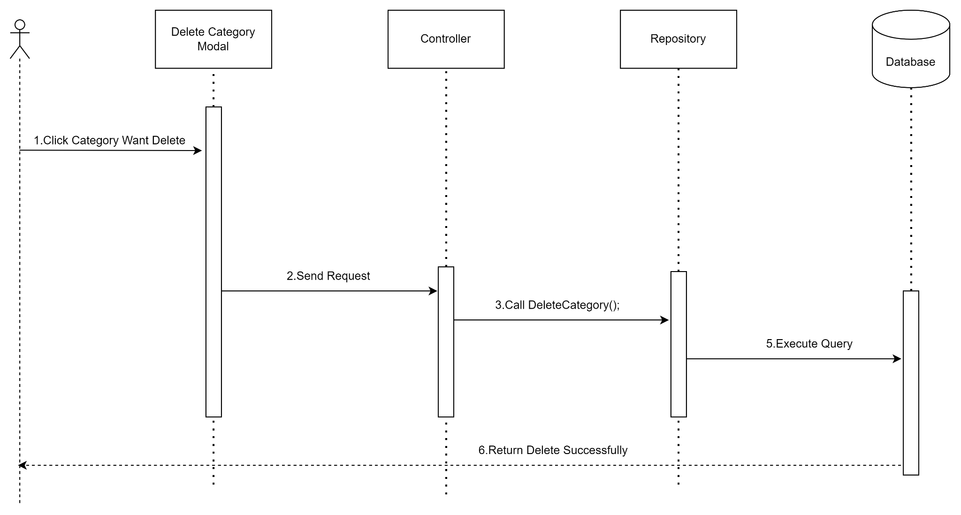

**Figure 6:** Delete category

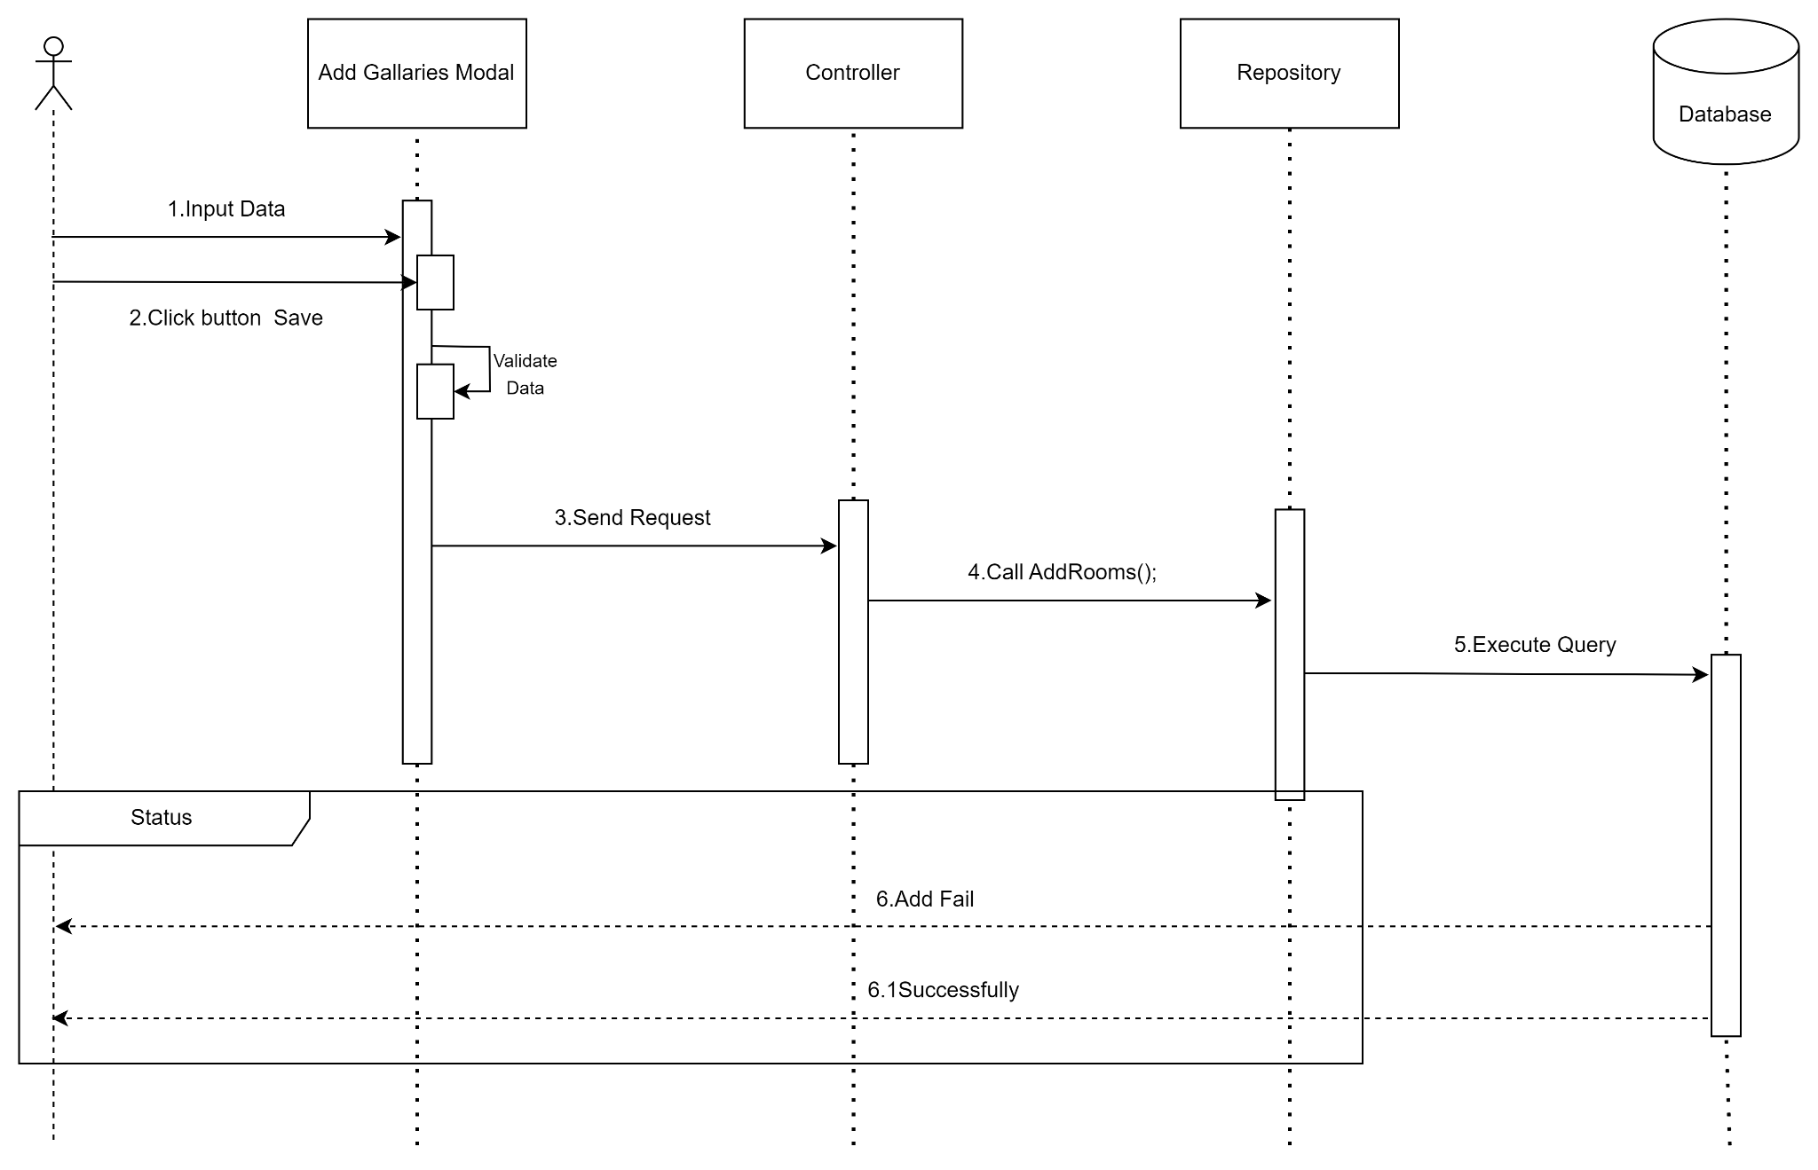

**Figure 7:** Add image to gallery

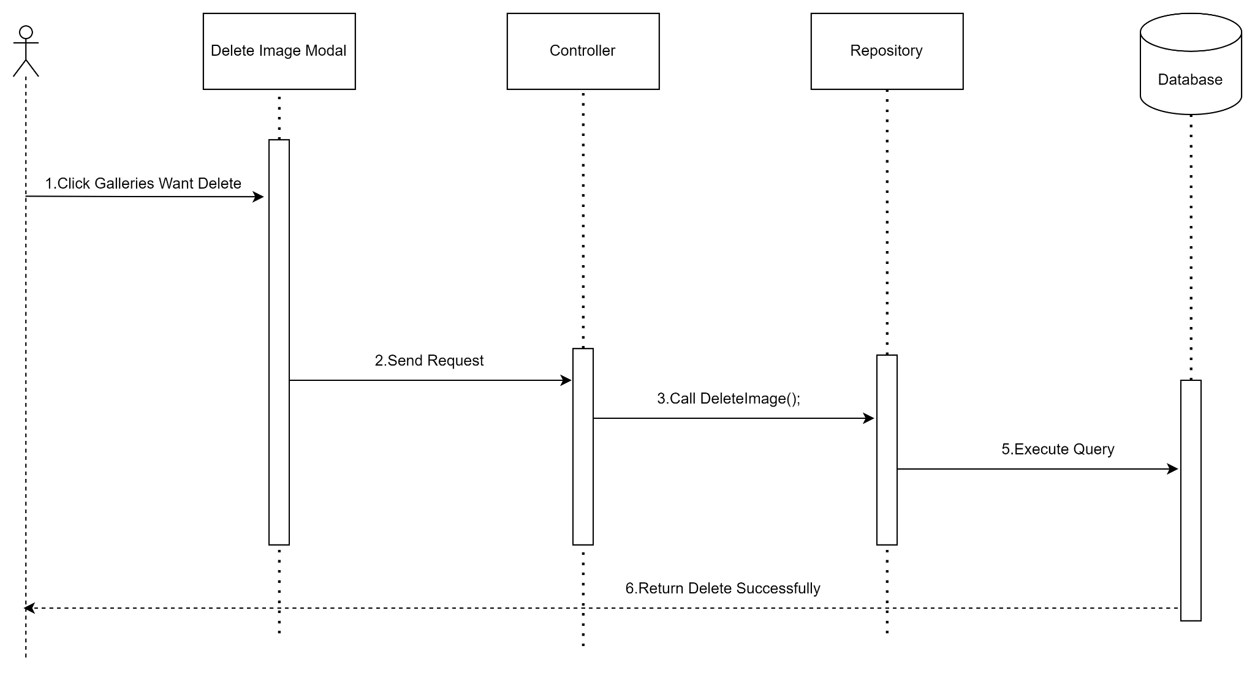

**Figure 8:** Delete image

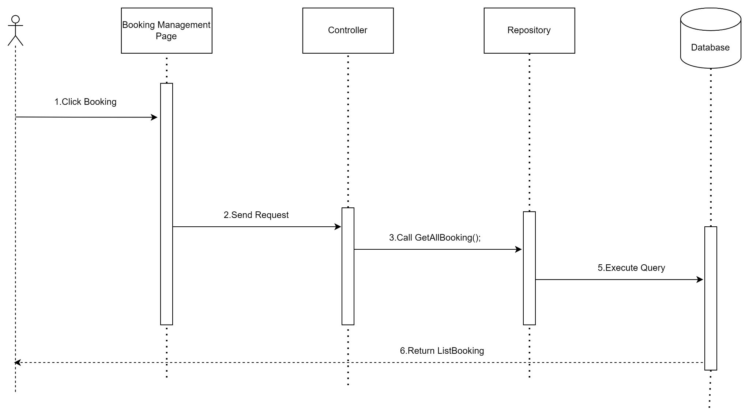

**Figure 9:** Get all booking

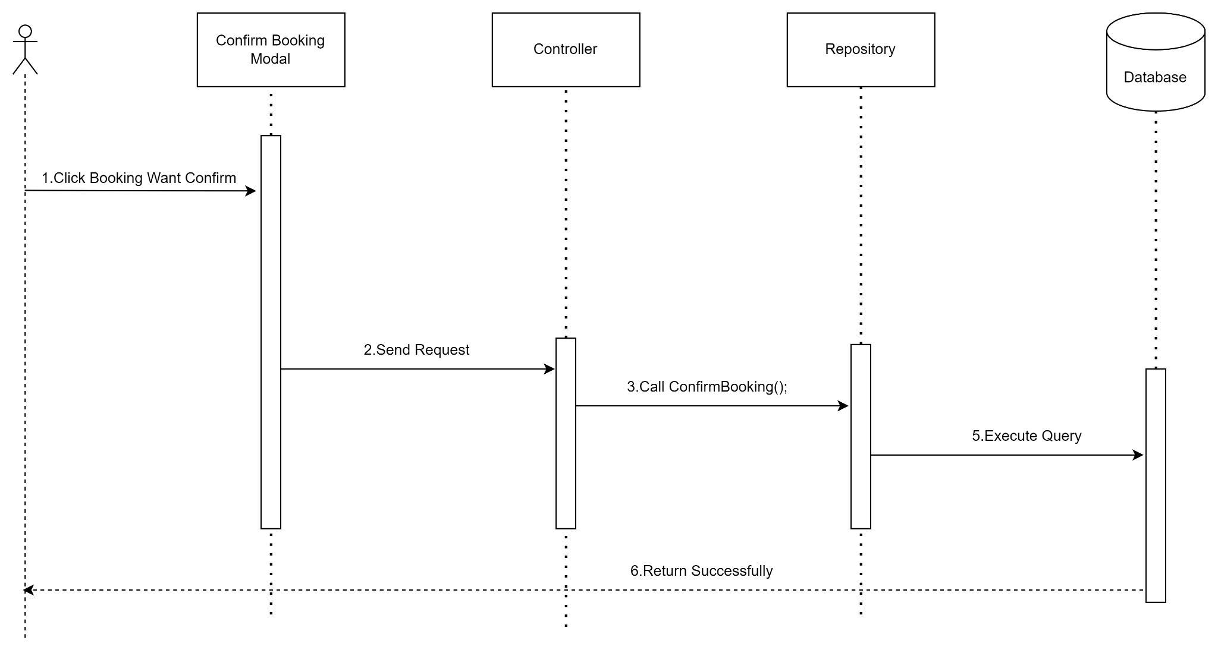

**Figure 10:** Confirm booking

# **Document and source code change management methods**

* Group members will be divided into 3 groups:
* Basic test
* Back-end
* Front-end
* Documents are managed using google doc, a text editing service from google. Members are invited to a working file and are granted permission to edit the document. Each time a document is modified, it is automatically saved when and what was modified and who modified it.
* As for the diagram, the team members will be added to a common working file like with a google doc.
* As for the source code leader, he creates a common source on git, the members clone the source and create personal branches and perform assigned tasks.
* After completing the work, members push the code to their personal branch and then notify the leader.
* Leader checks and merges members' code through a common branch.
* After completing all work, the project leader merges the code of all members into the common branch and checks to see if the source code is working properly.
* When the source code is stable, the leader merges the code from that common branch to the main branch of the source and ends the project.

# **UI Design**

## Authentication

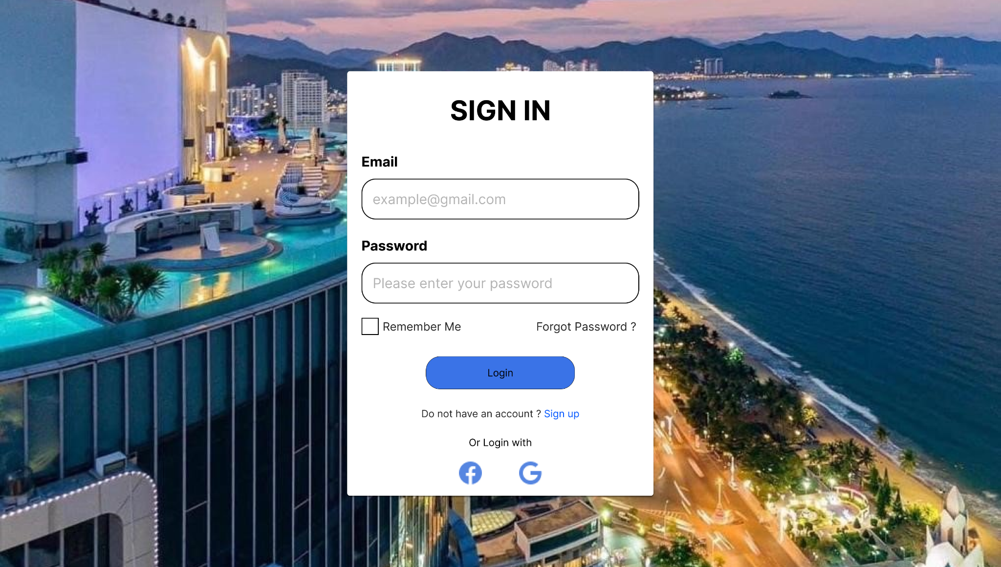

**Figure 1.1:** Login Page

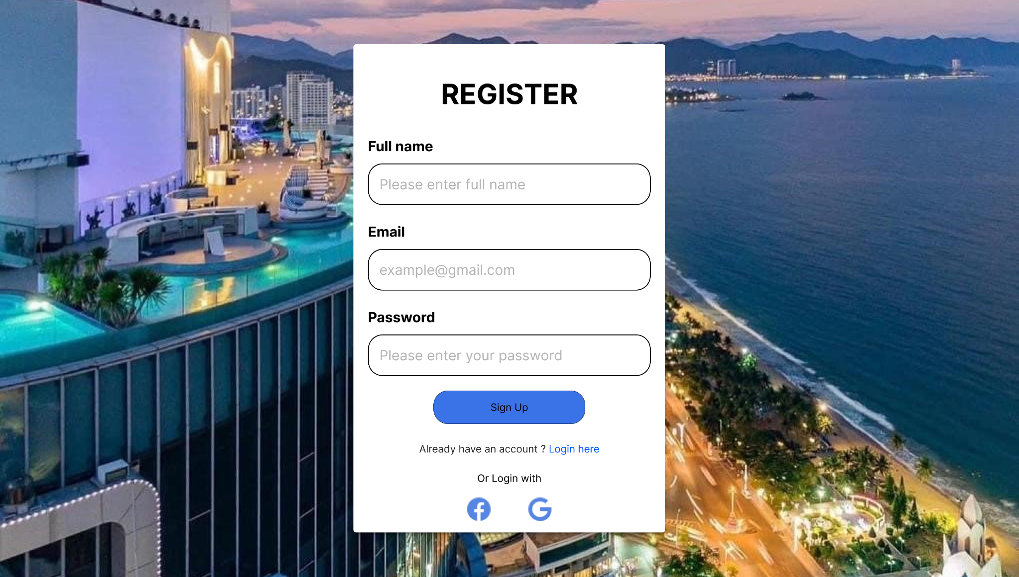

**Figure 1.2:** Register Page

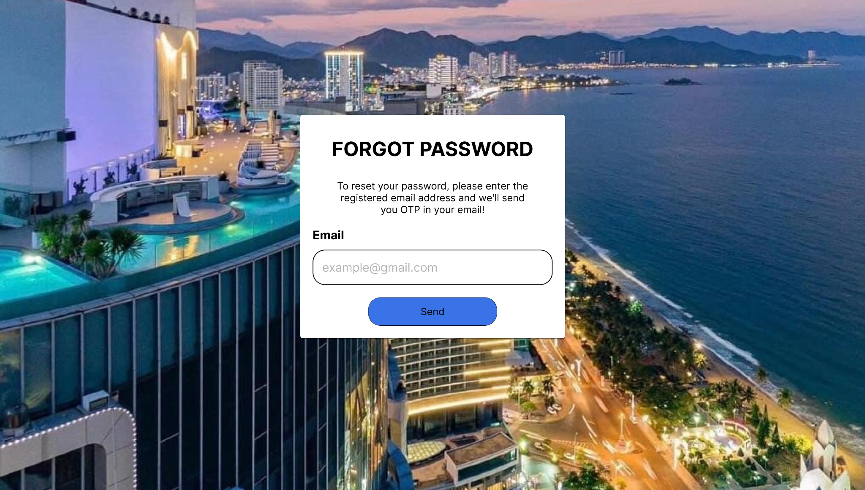

**Figure 1.3.1:** Forgot Password Page - Send Email

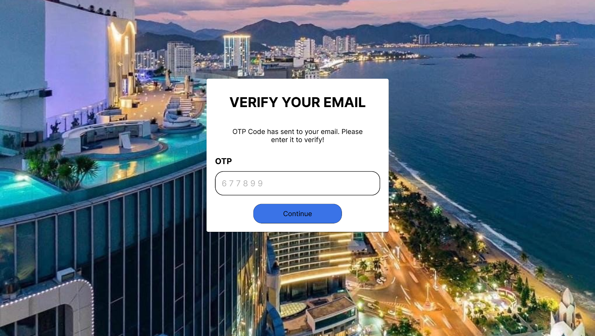

**Figure 1.3.2:** Forgot Password Page - Verify Email

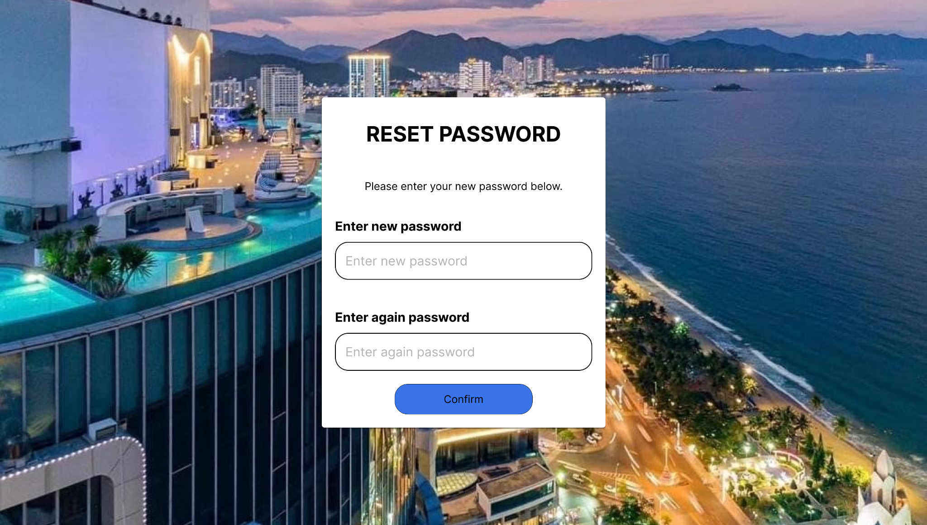

**Figure 1.3.3:** Forgot Password Page - Reset Password

## Customer



**Figure 2.1.1:** Header Components - Not Logged



**Figure 2.1.2:** Header Components - Is Logged

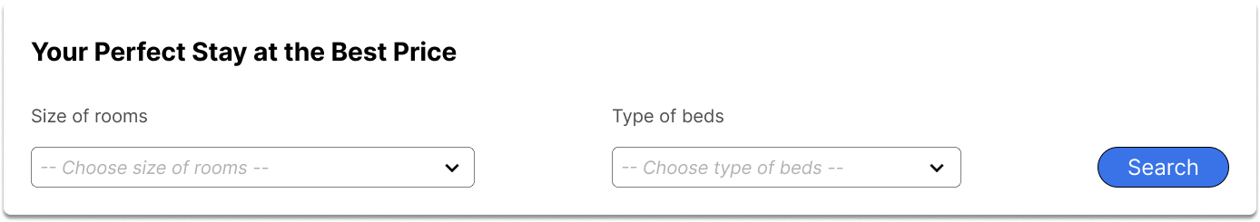

**Figure 2.2:** Search Component

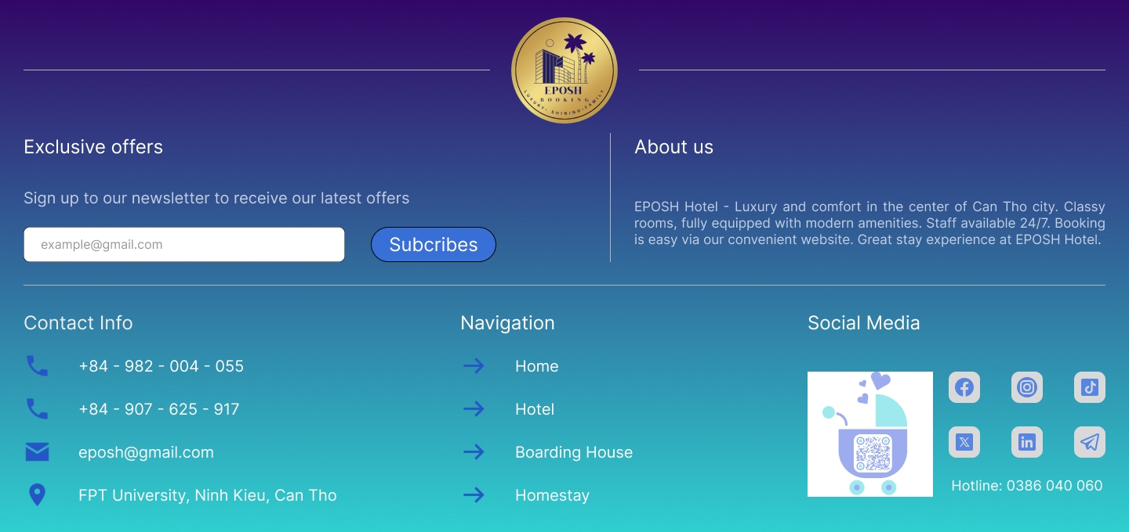

**Figure 2.3:** Footer Component

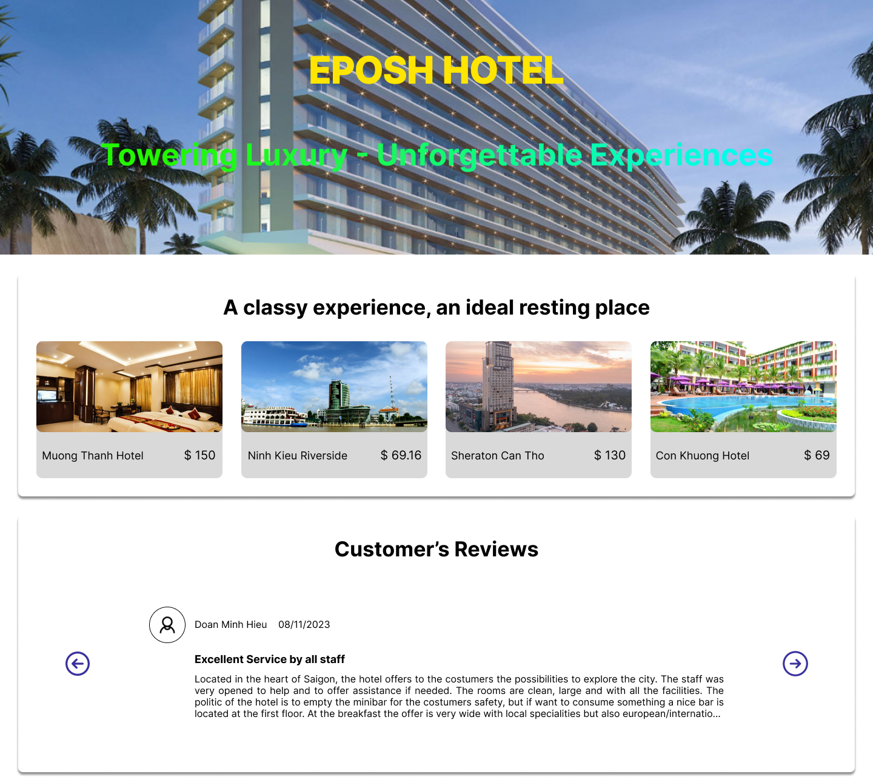

**Figure 2.4:** Home Page

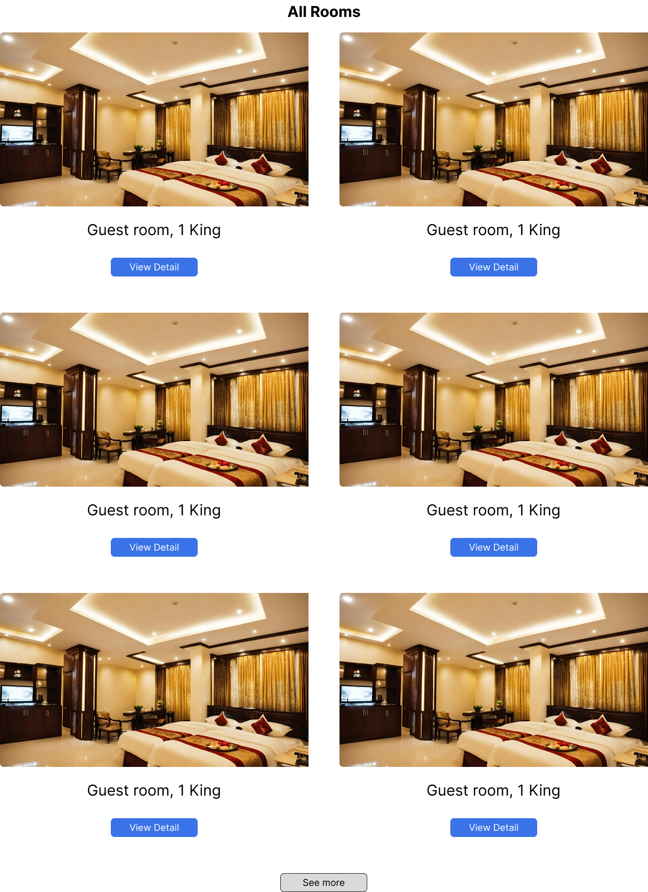

**Figure 2.5:** Rooms Page

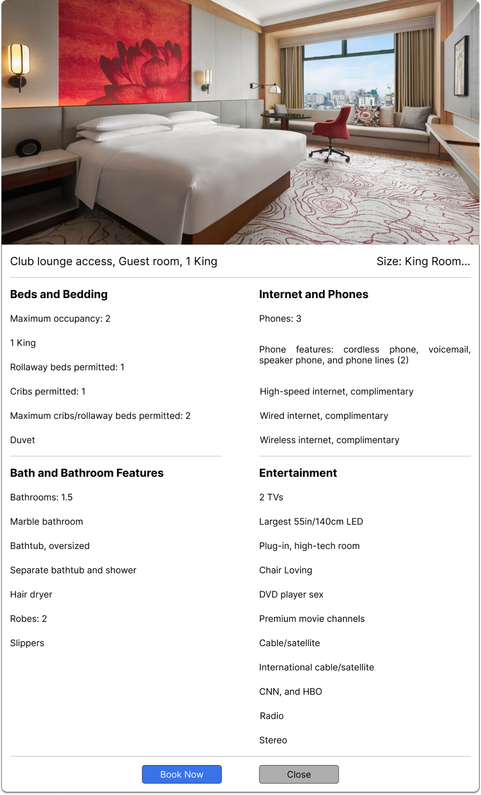

**Figure 2.6:** Detail Room Modal

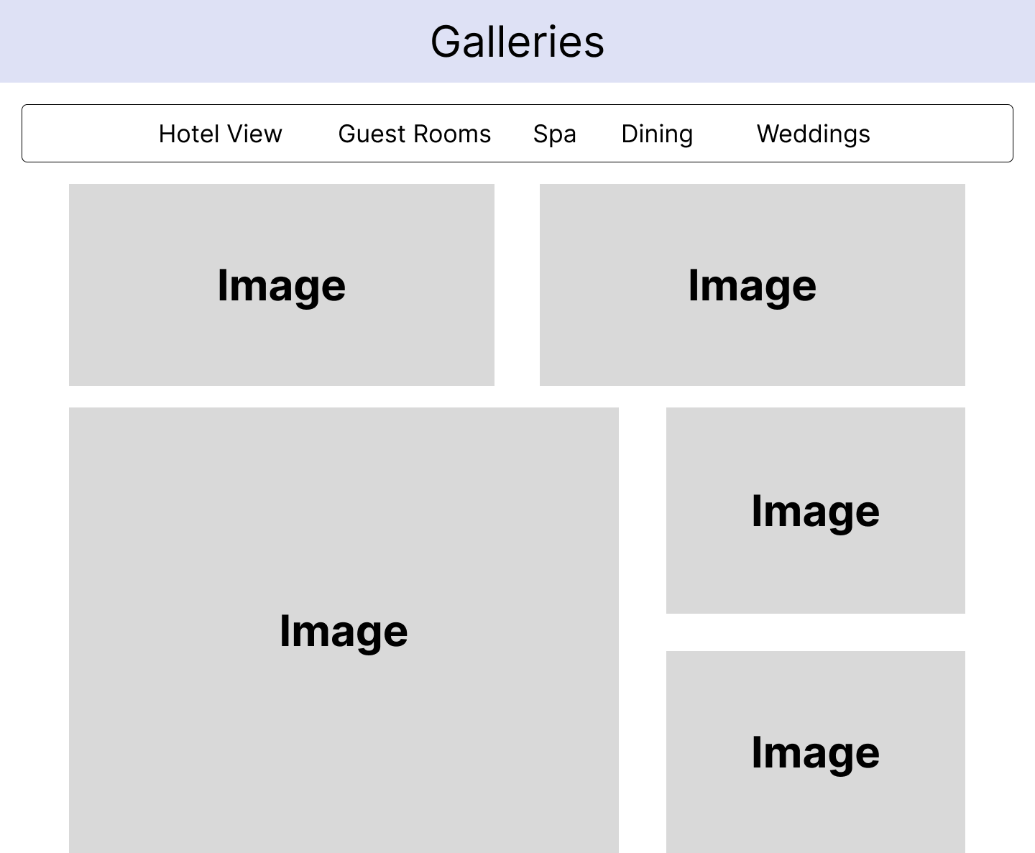

**Figure 2.7:** Galleries Page

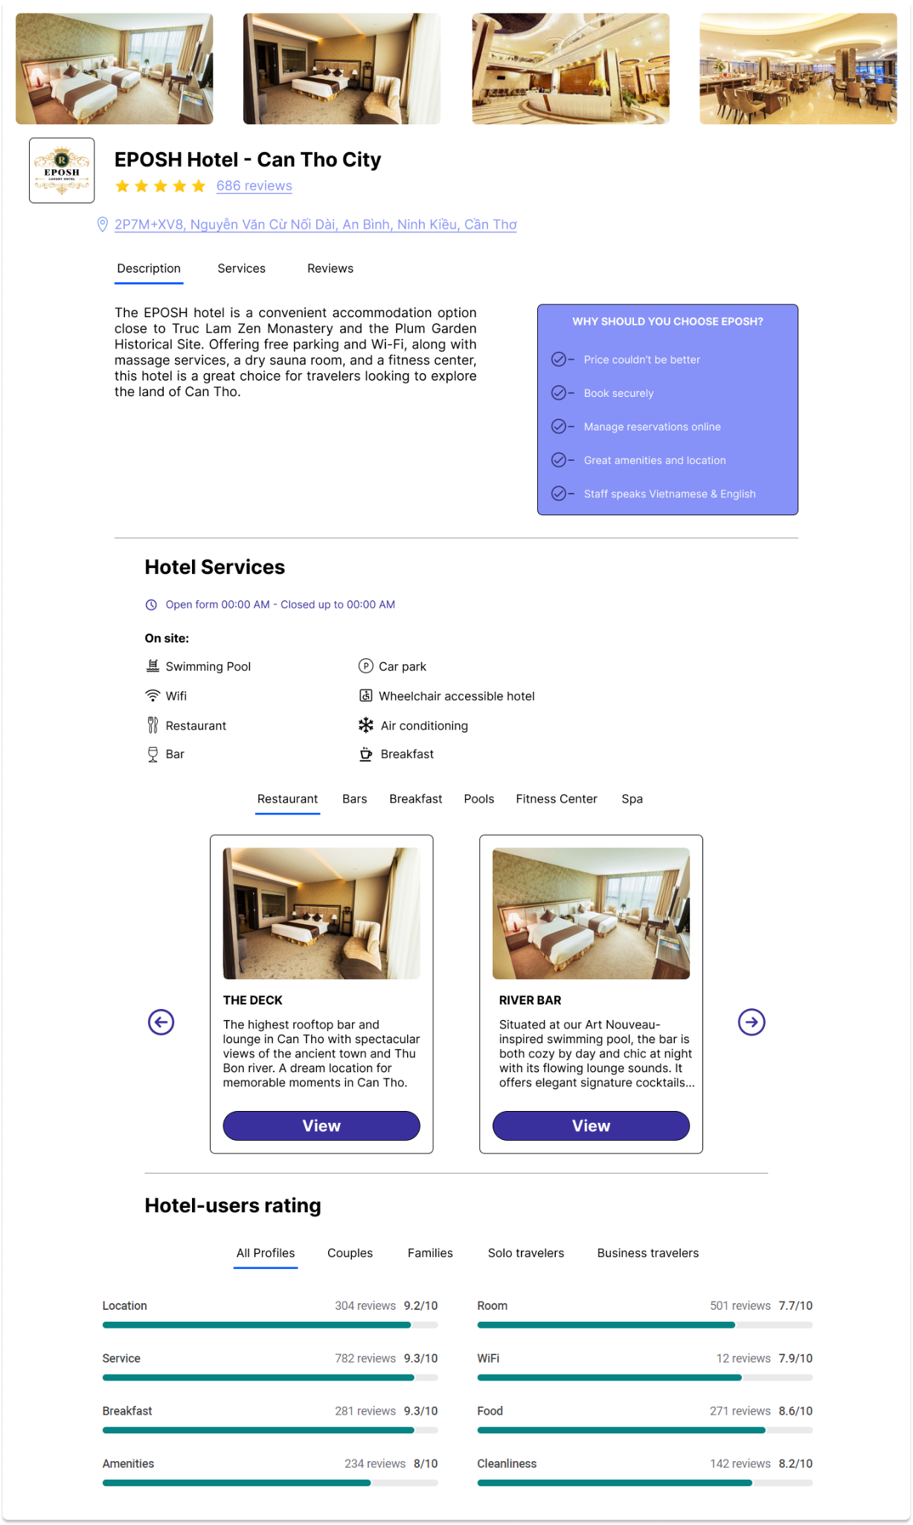

**Figure 2.8:** About Us Page

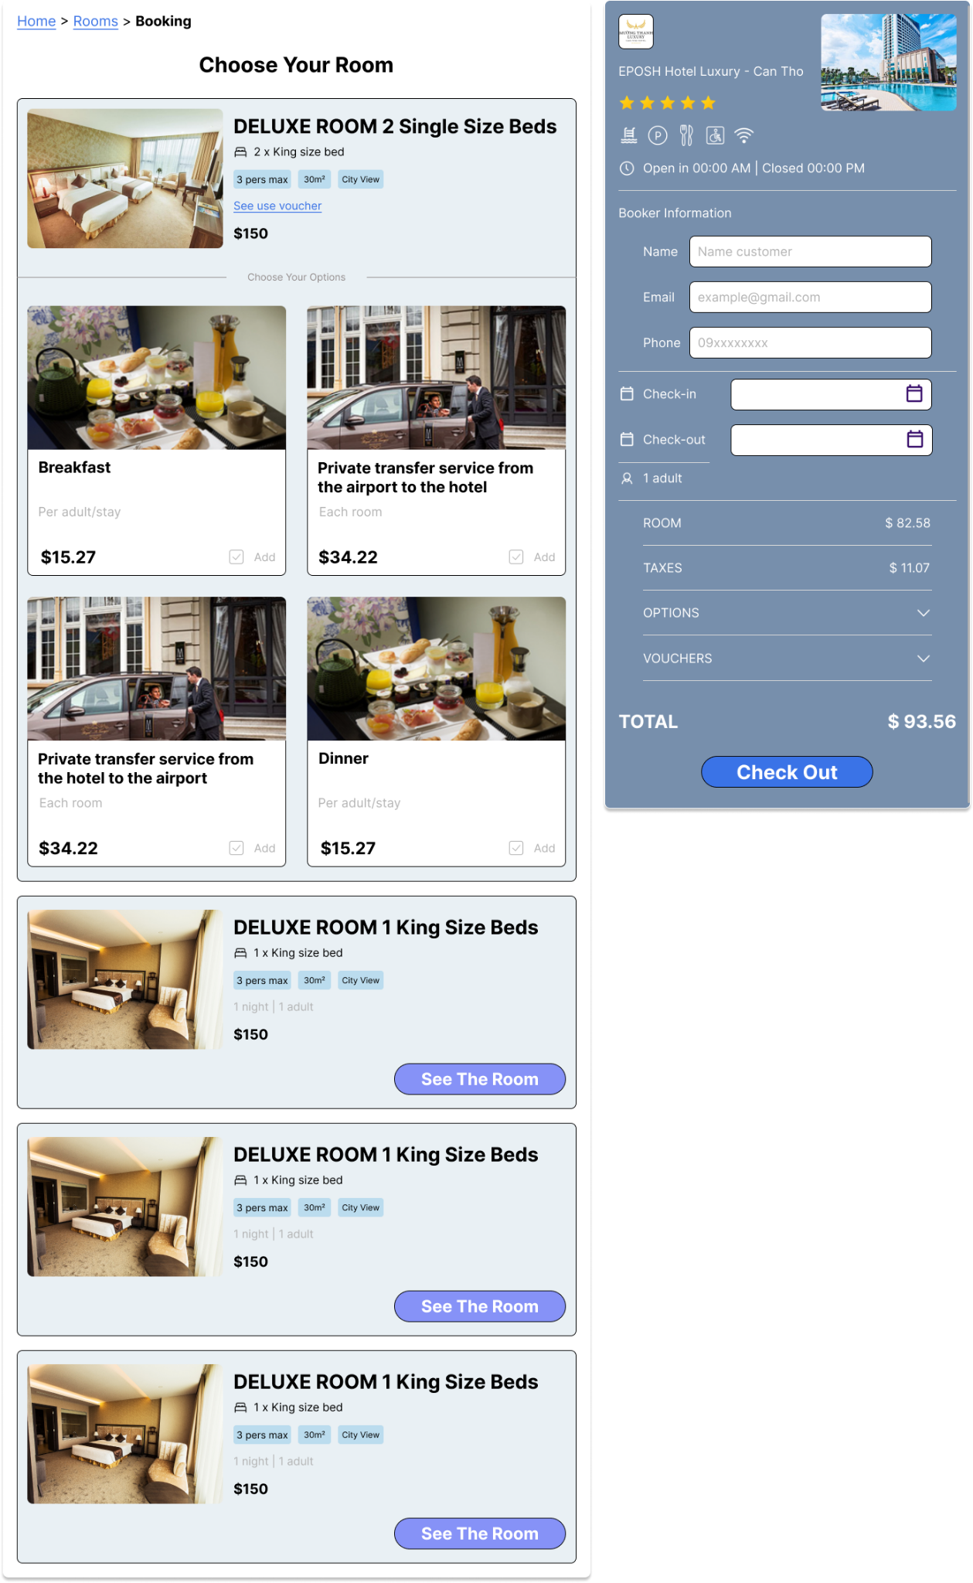

**Figure 2.9:** Checkout Page

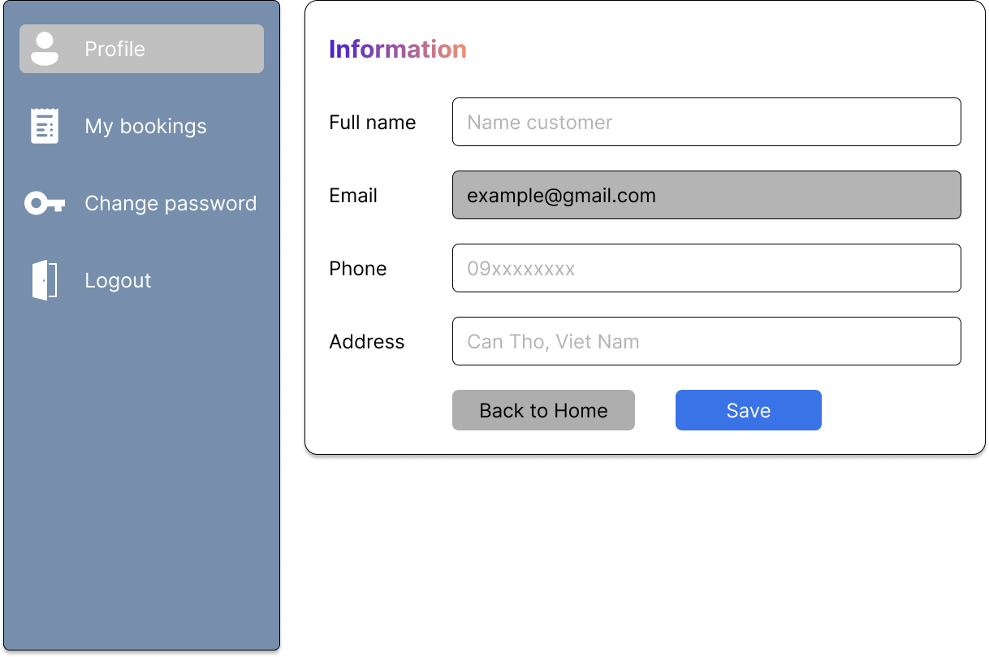

**Figure 2.10:** Profile Page

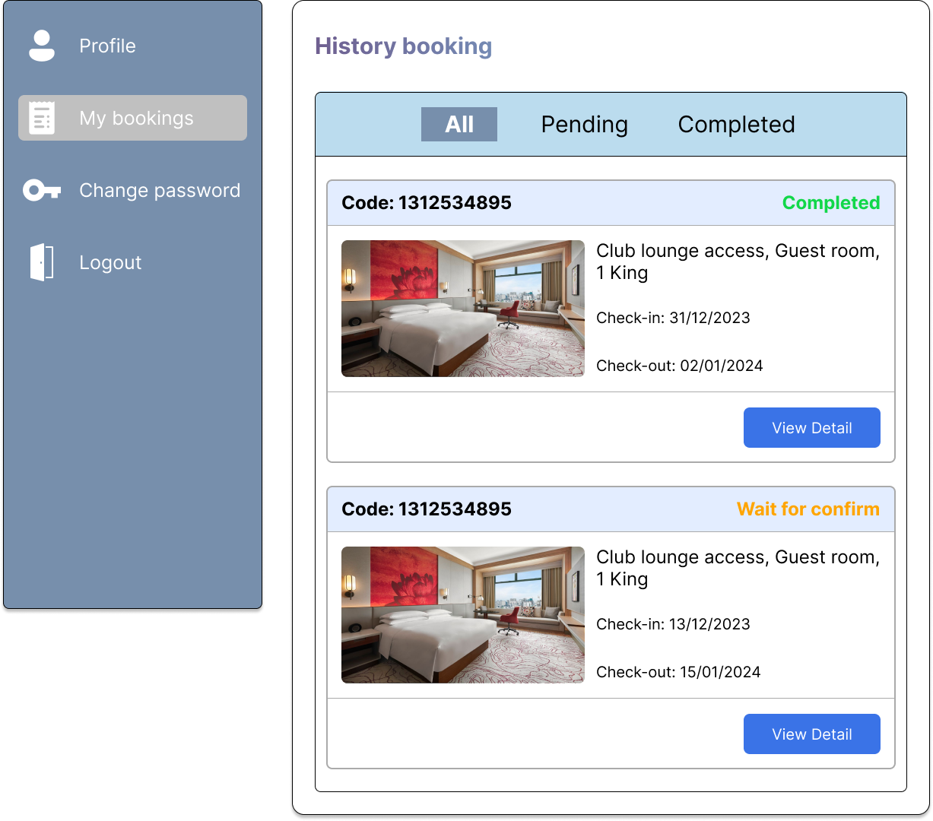

**Figure 2.11:** History Booking Page

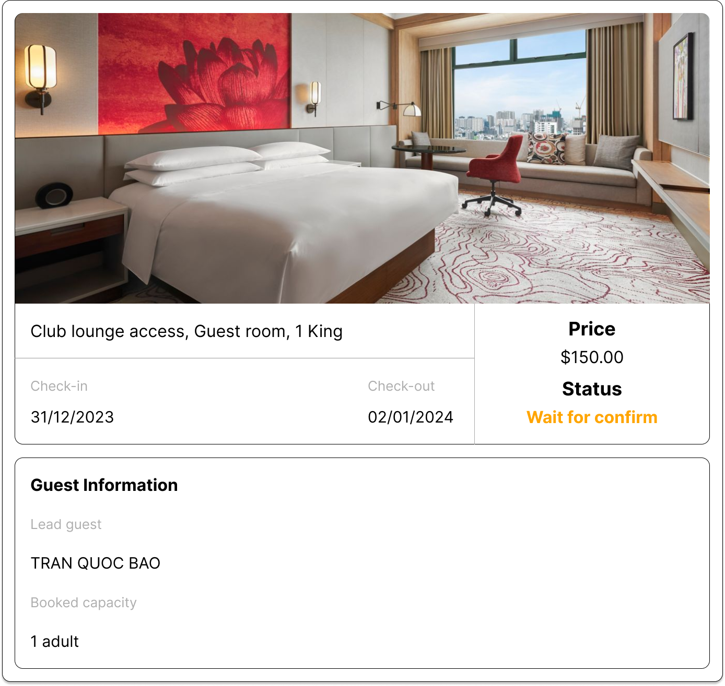

**Figure 2.12:** Detail Booking Modal

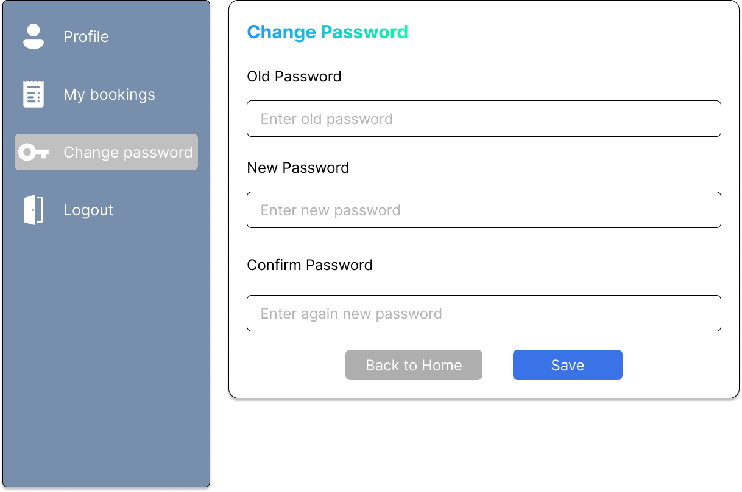

**Figure 2.13:** Change Password Page

## Admin

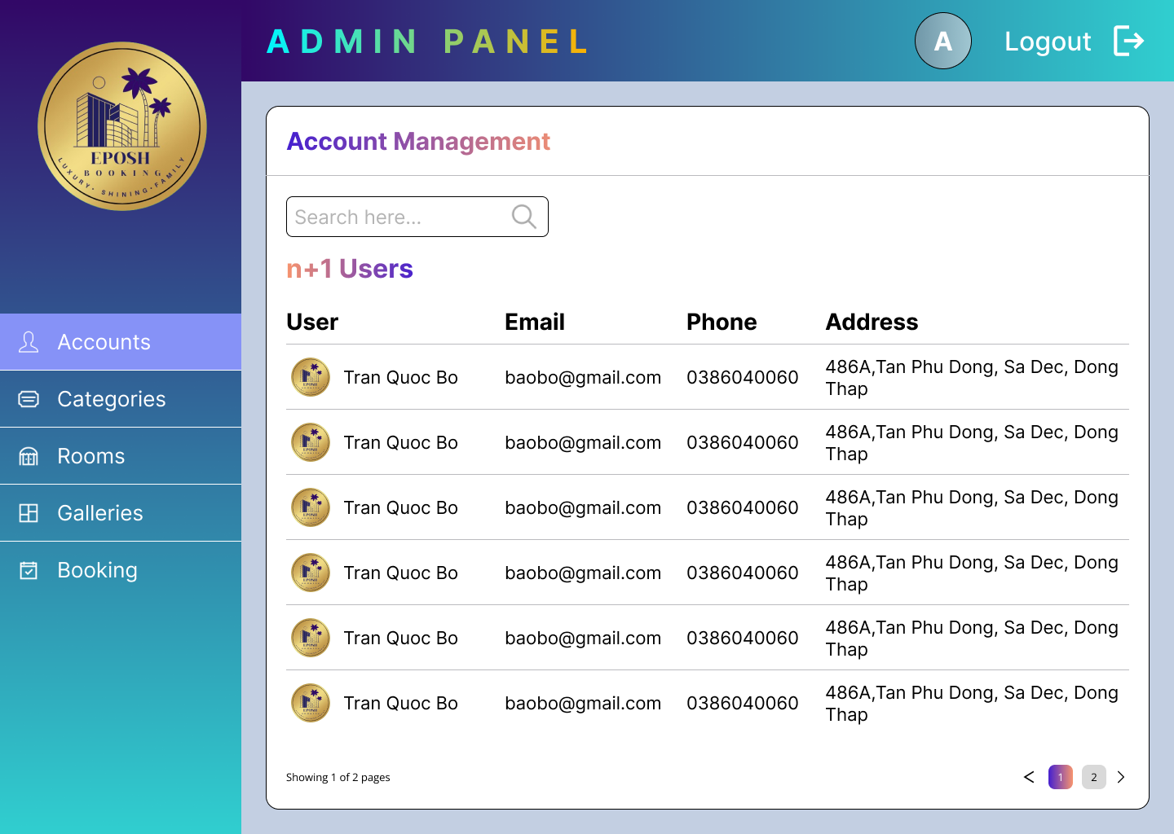

**Figure 3.1:** Account Management Page

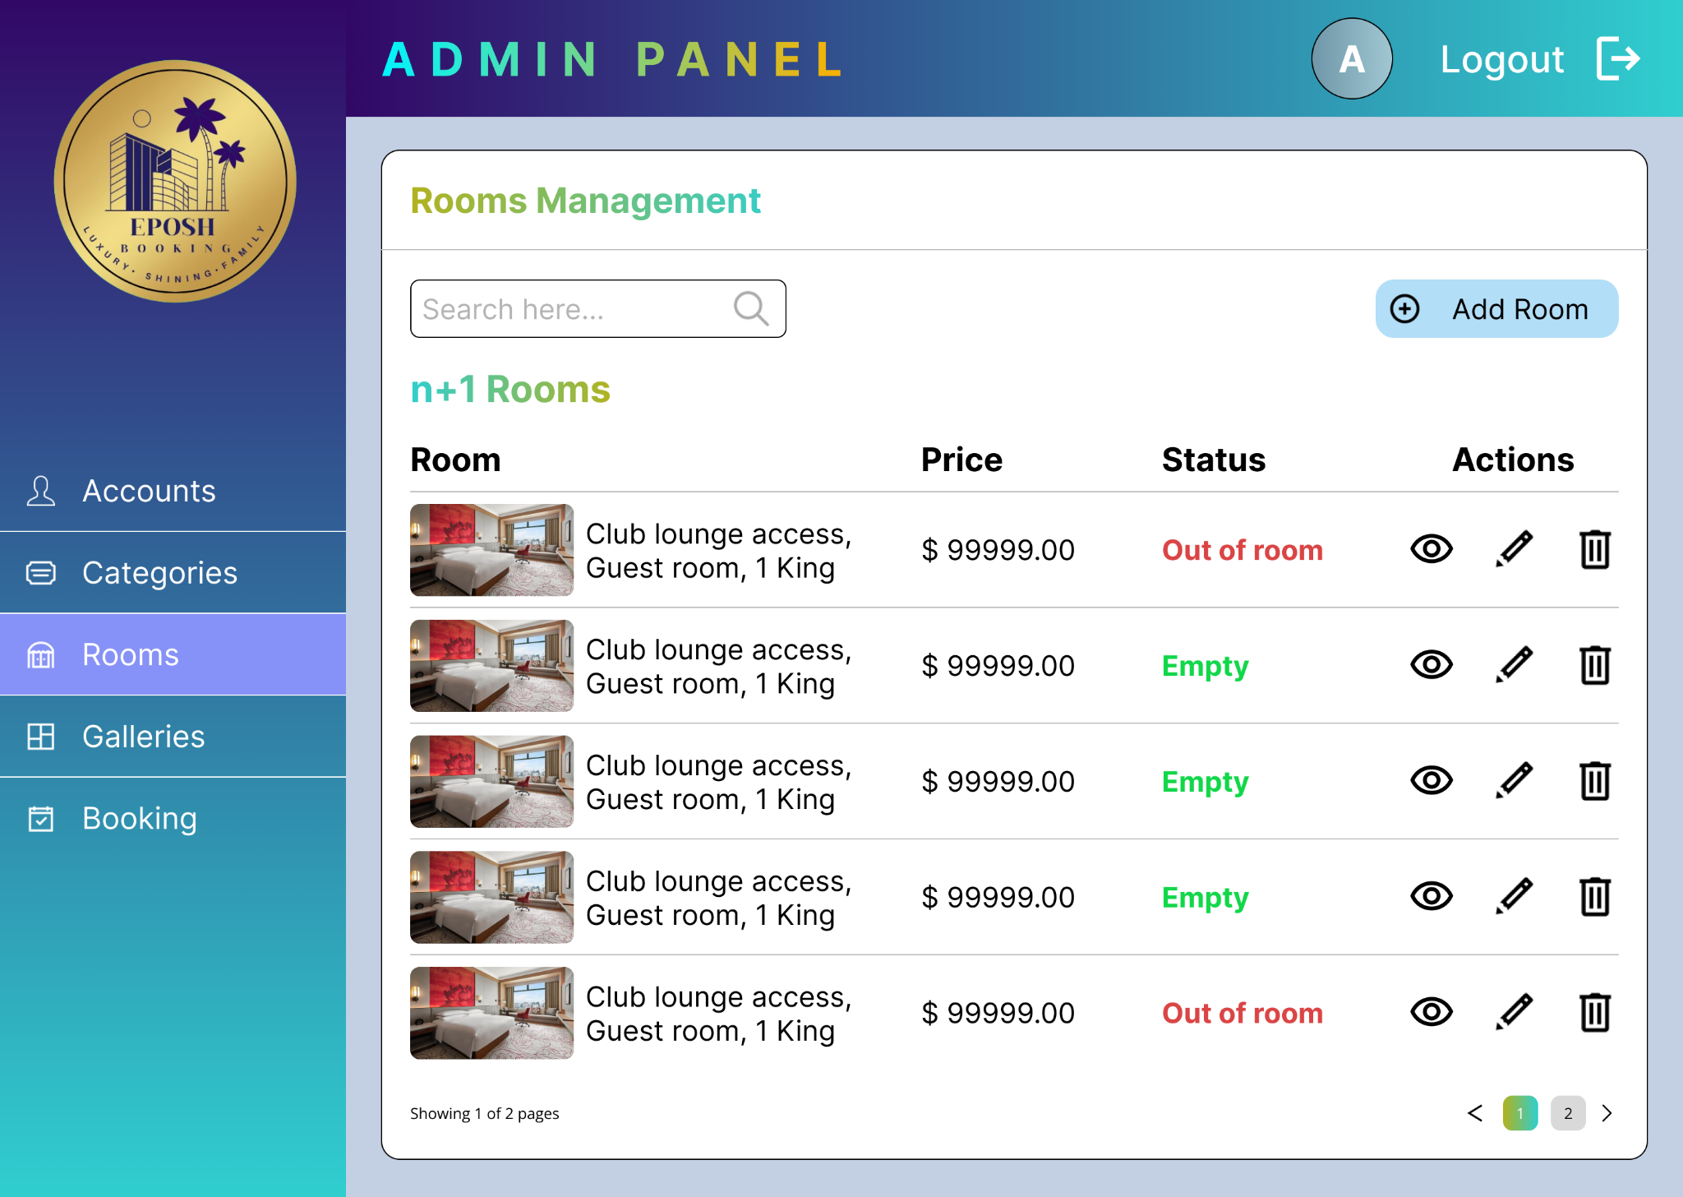

**Figure 3.2:** Rooms Management Page

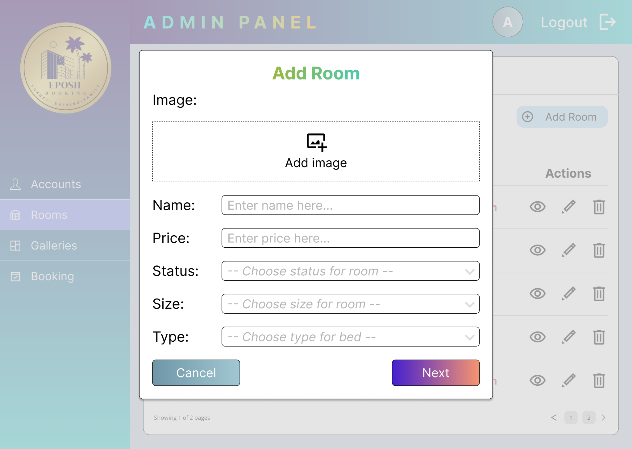

**Figure 3.2.1.1:** Add Room Modal - Step one

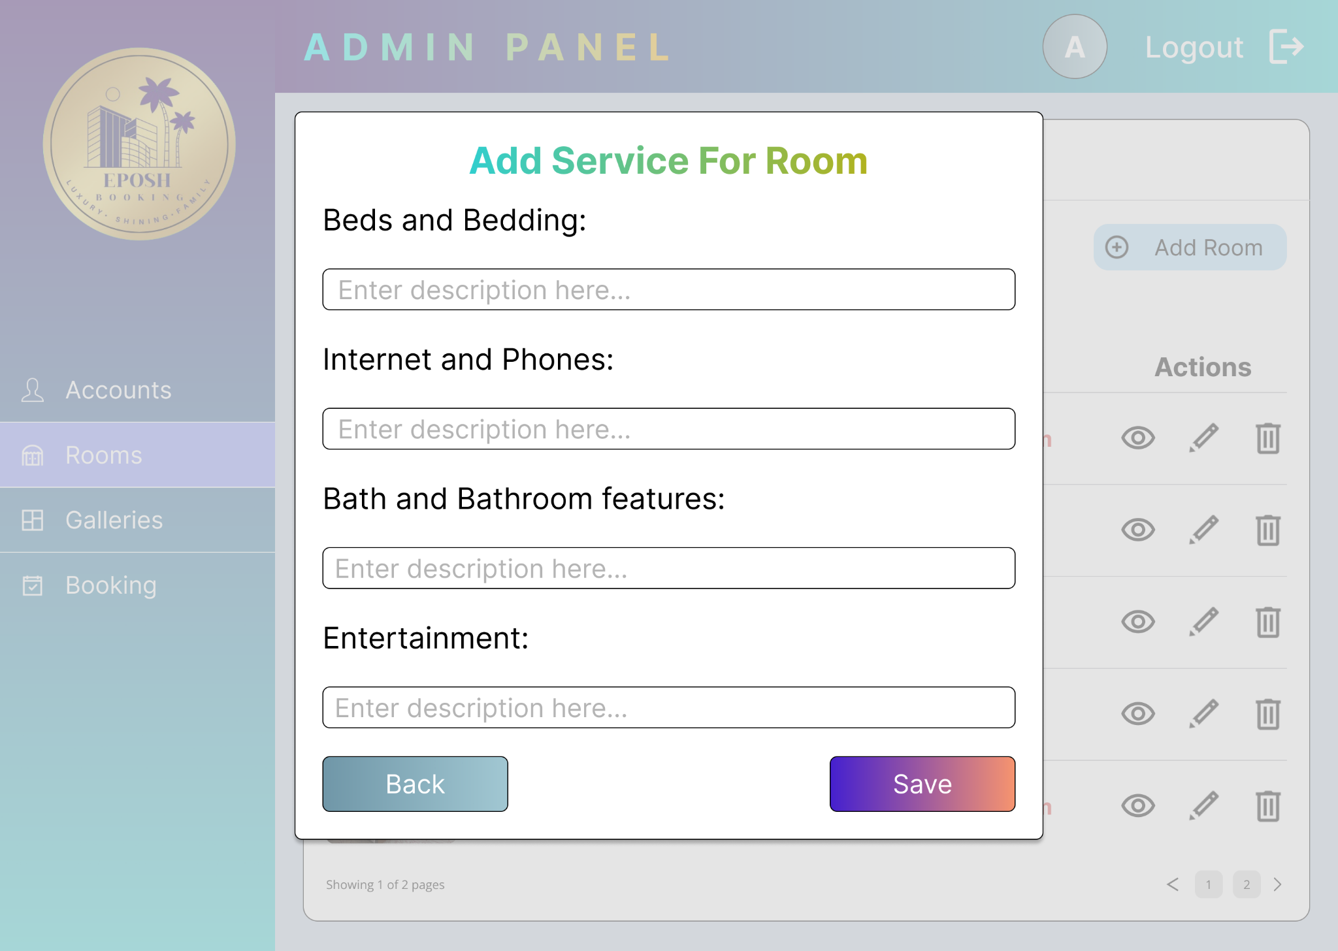

**Figure 3.2.1.2:** Add Room Modal - Step two

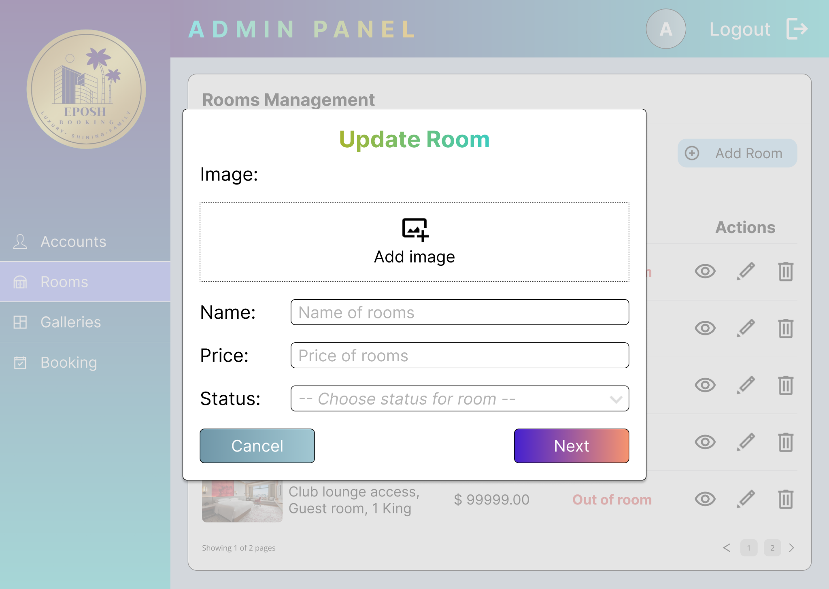

**Figure 3.2.2.1:** Update Room Modal - Step One

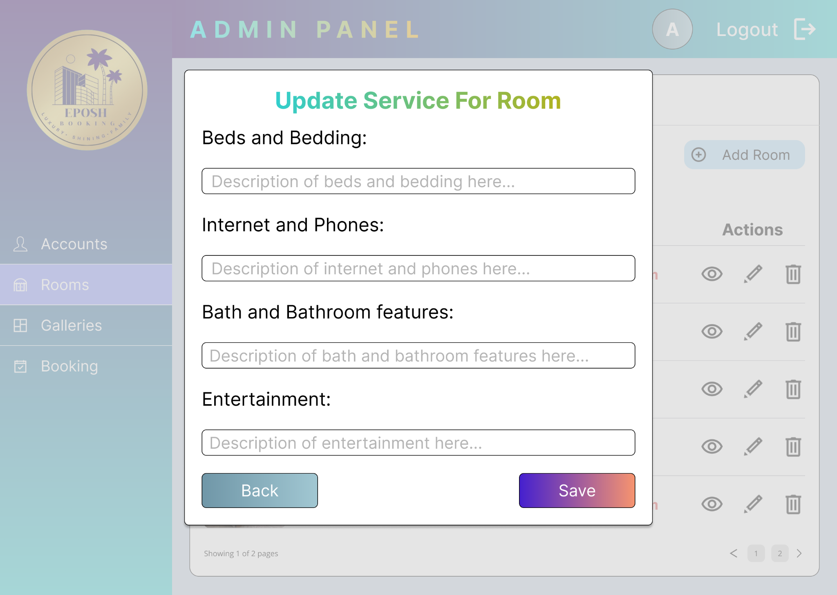

**Figure 3.2.2.2:** Update Room Modal - Step two

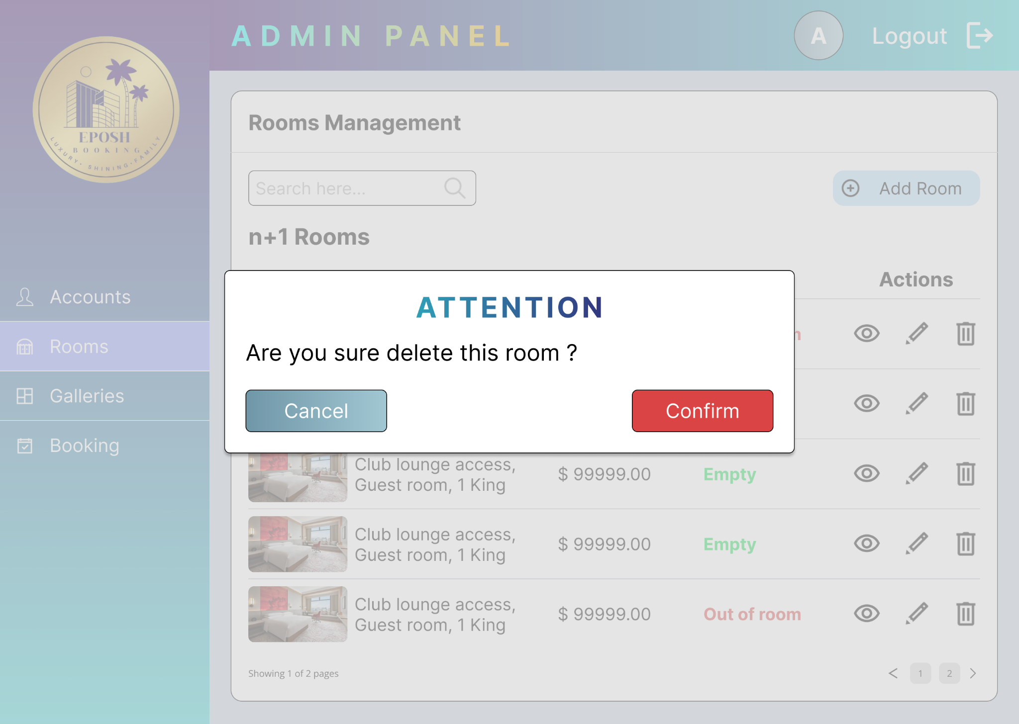

**Figure 3.2.3:** Delete Room Modal

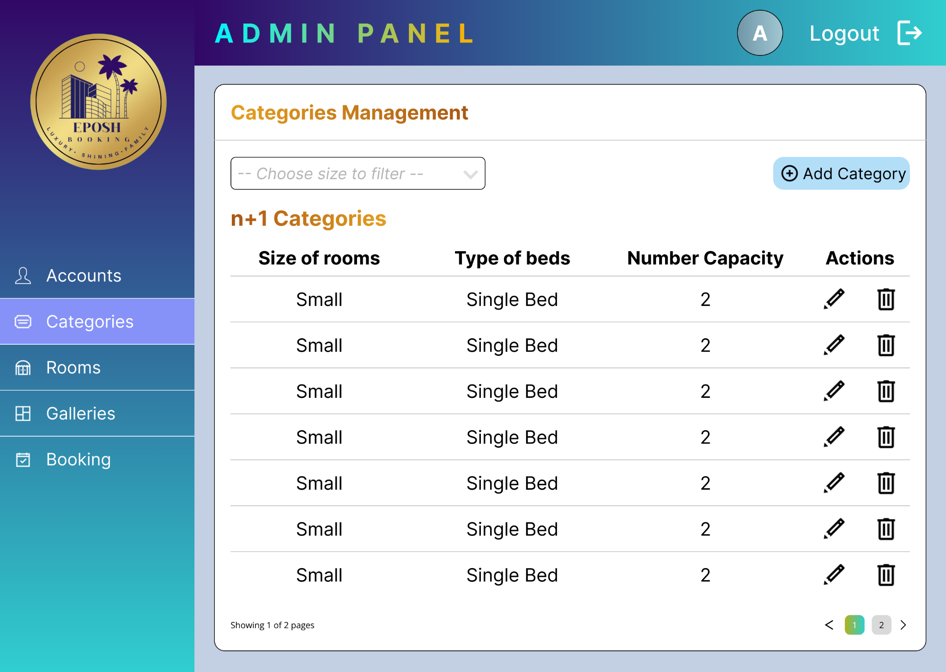

**Figure 3.3:** Categories Management Page

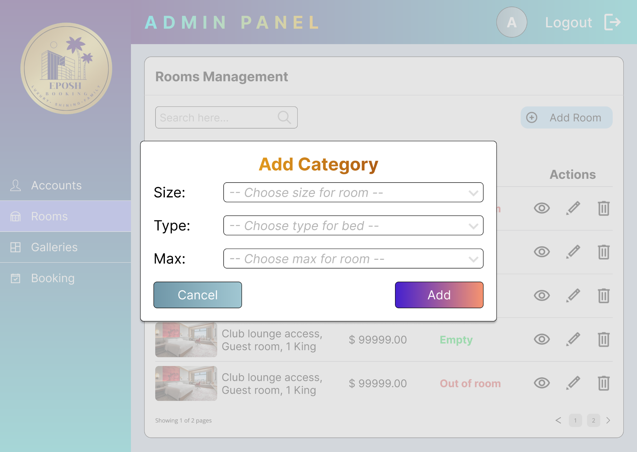

**Figure 3.3.1:** Add Category Modal

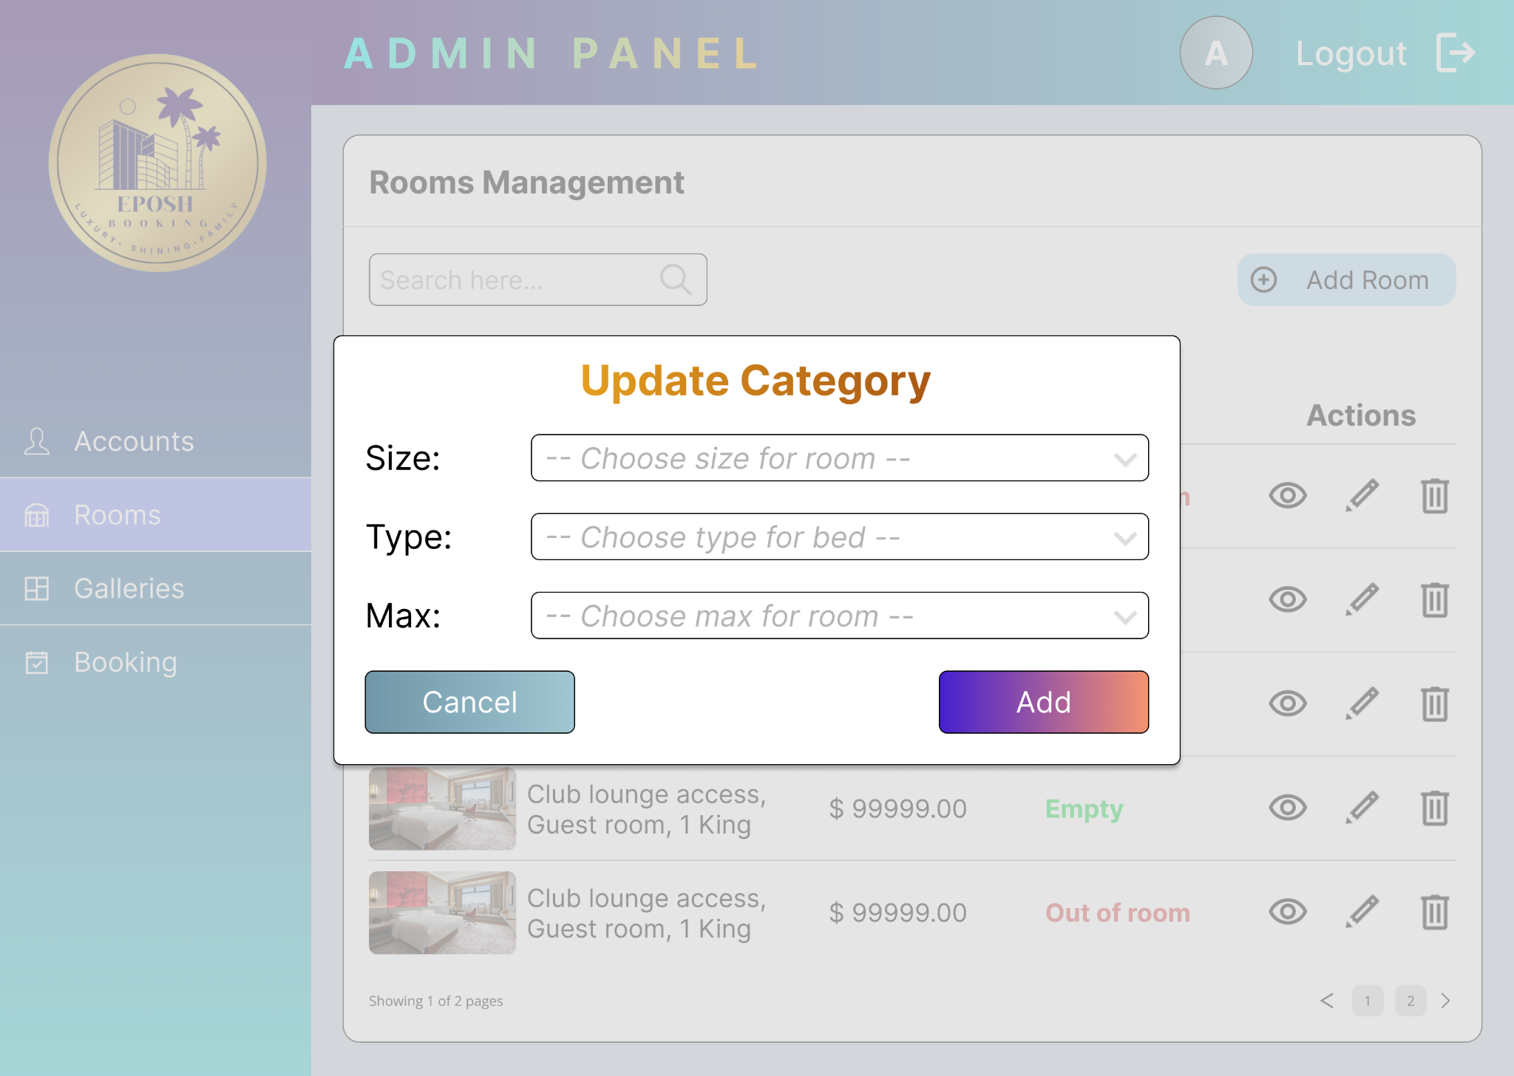

**Figure 3.3.2:** Update Category Modal

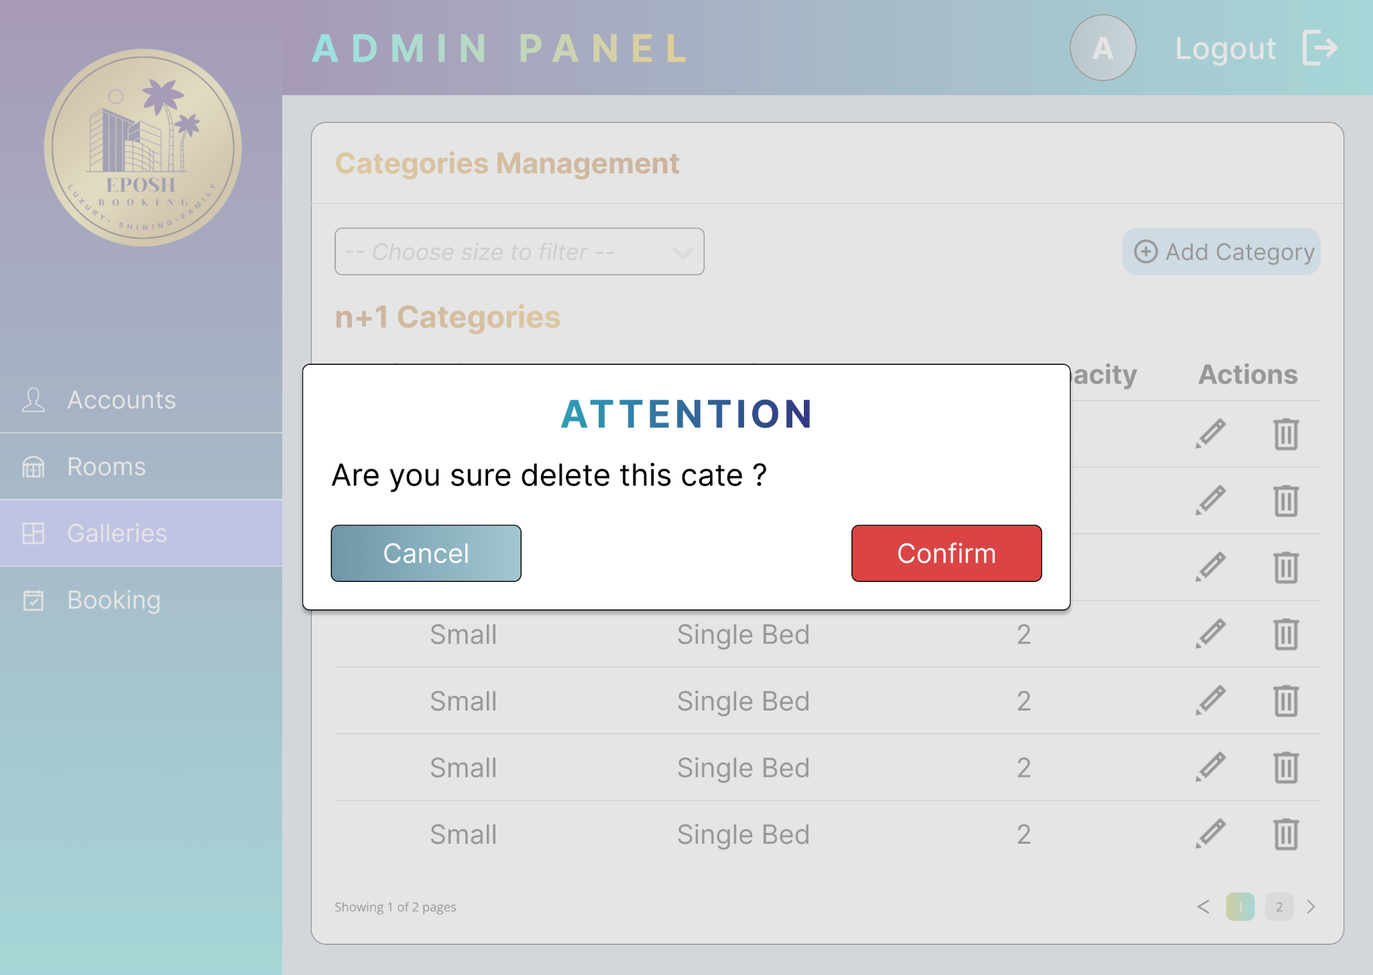

**Figure 3.3.3:** Delete Categories Modal

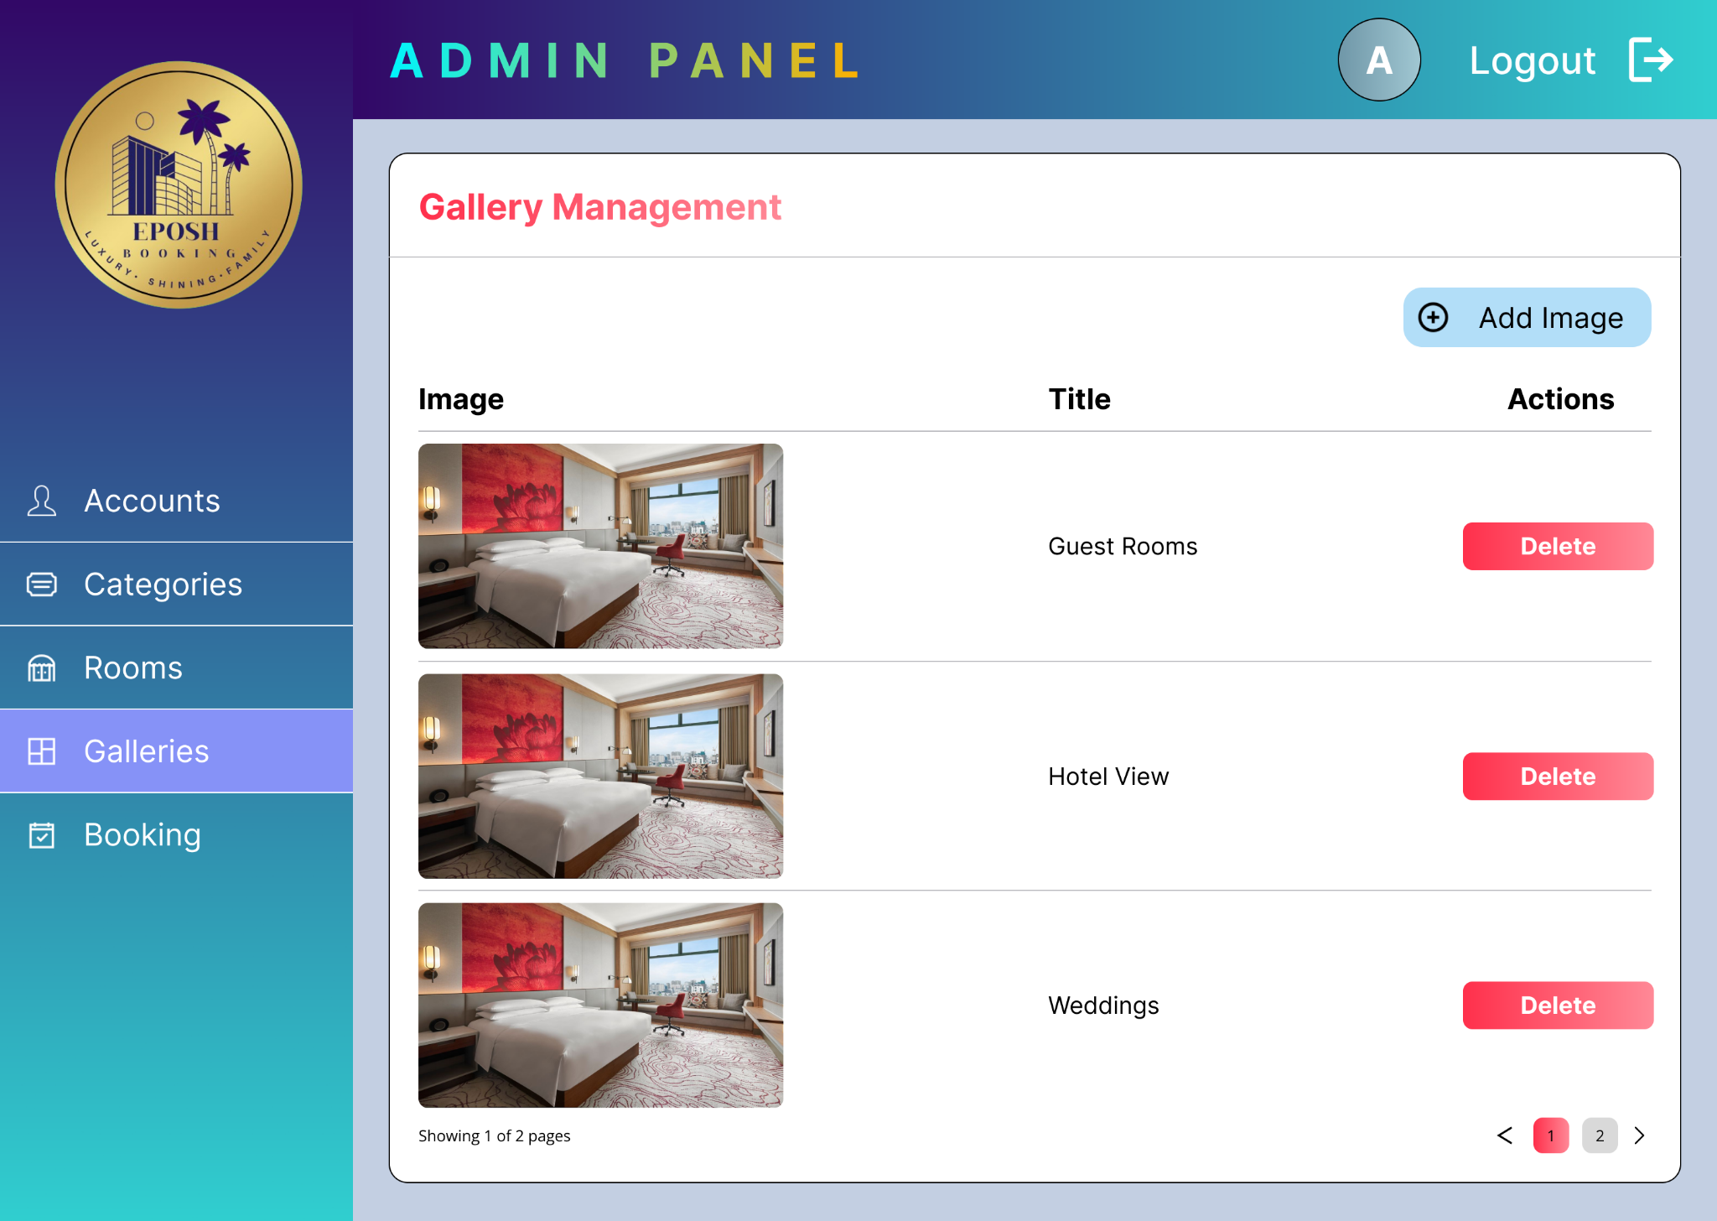

**Figure 3.4:** Galleries Management Page

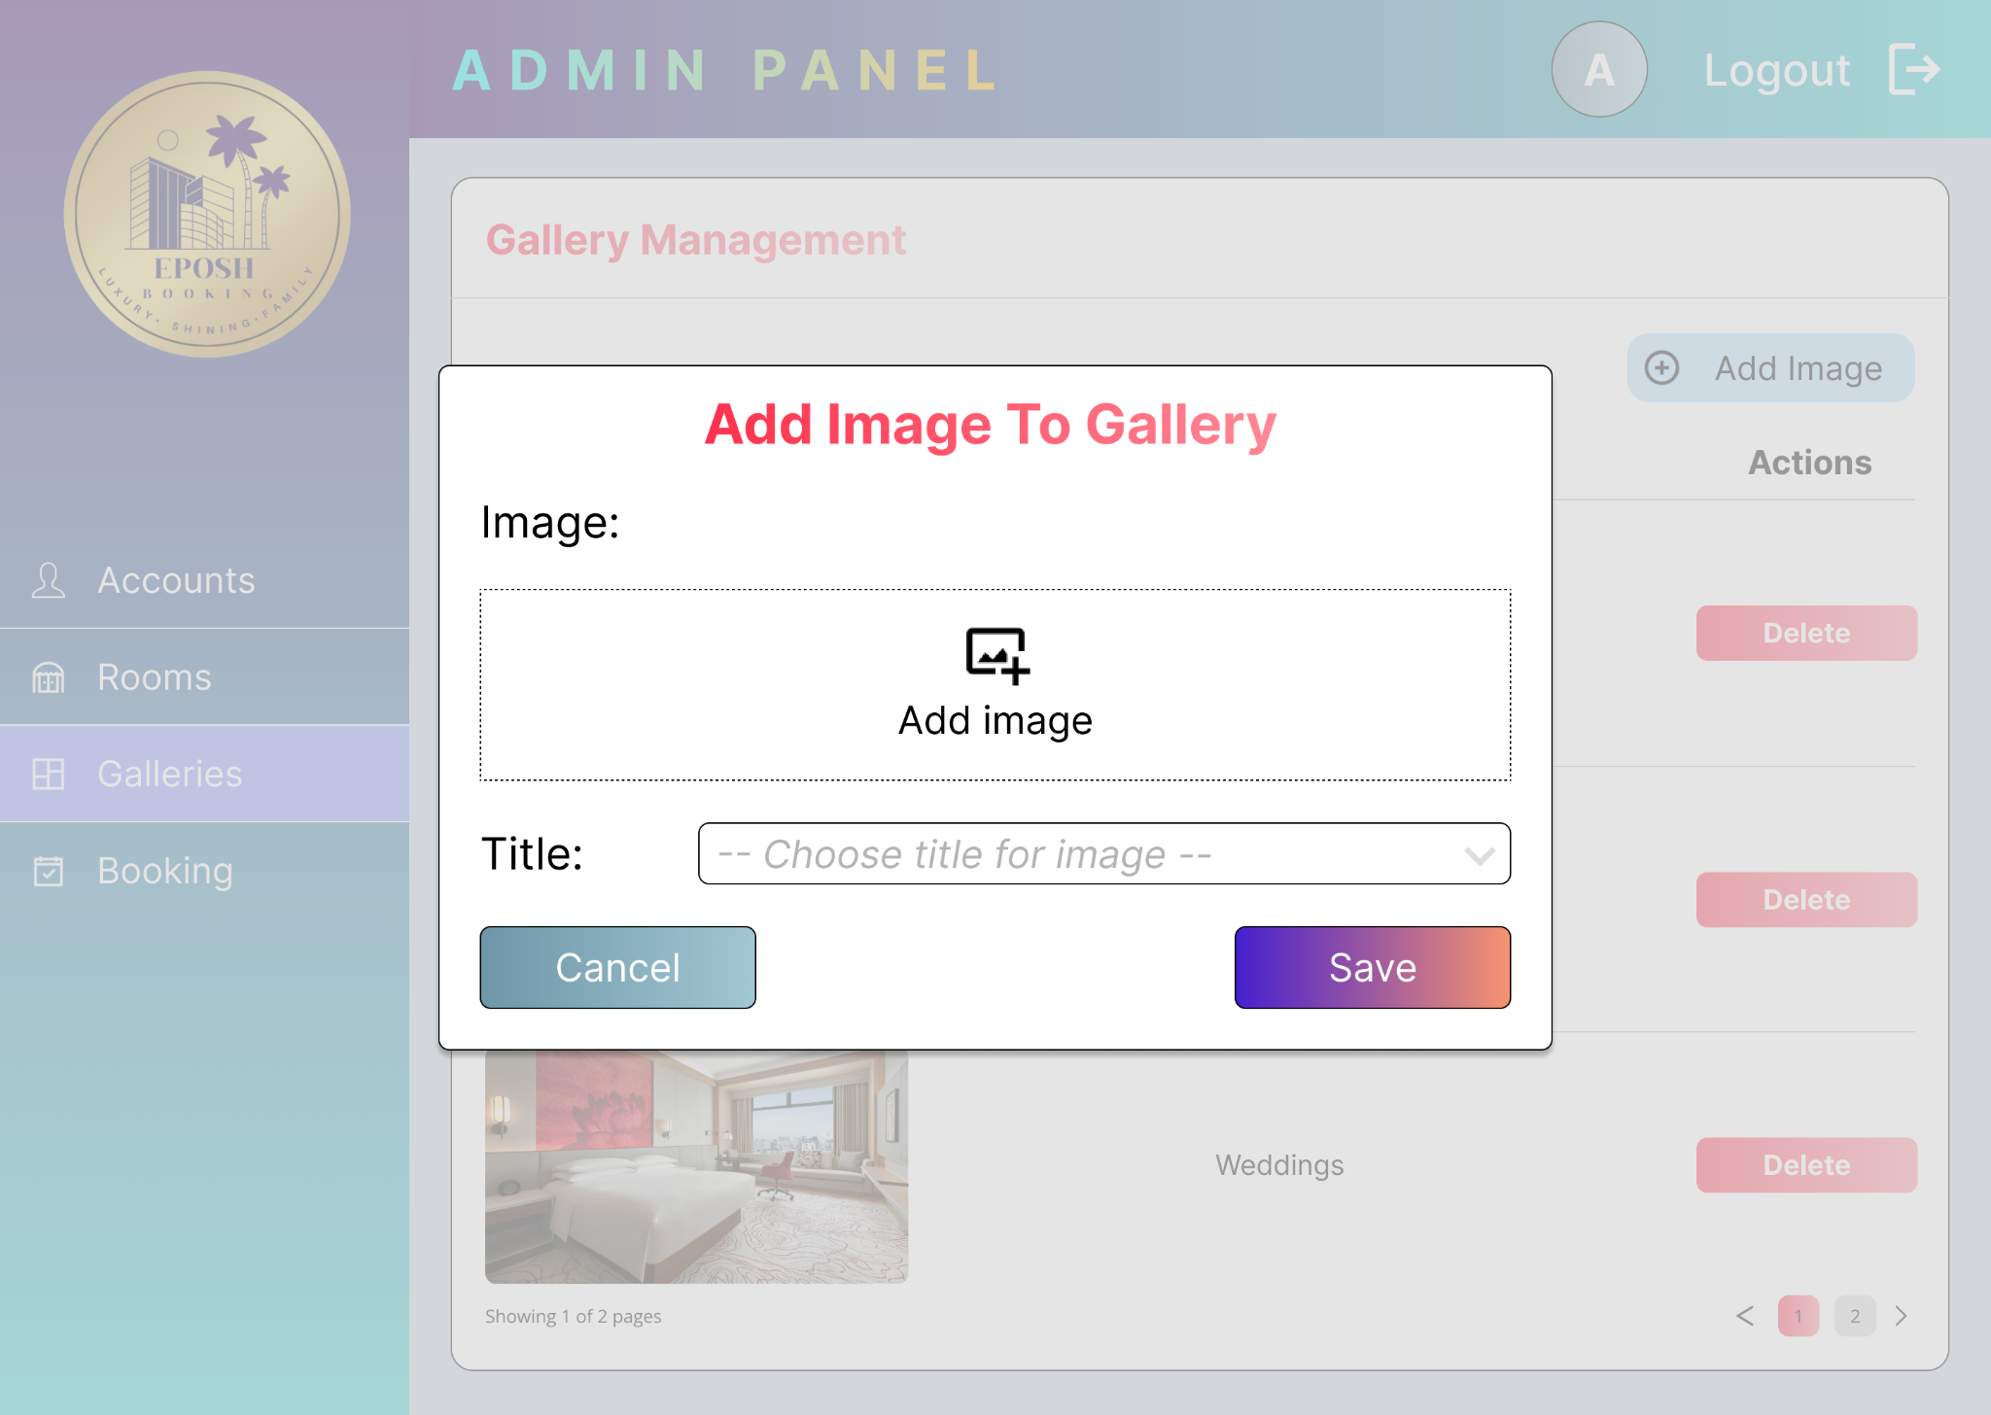

**Figure 3.4.1:** Add Image Modal



**Figure 3.4.2:** Delete Image Modal

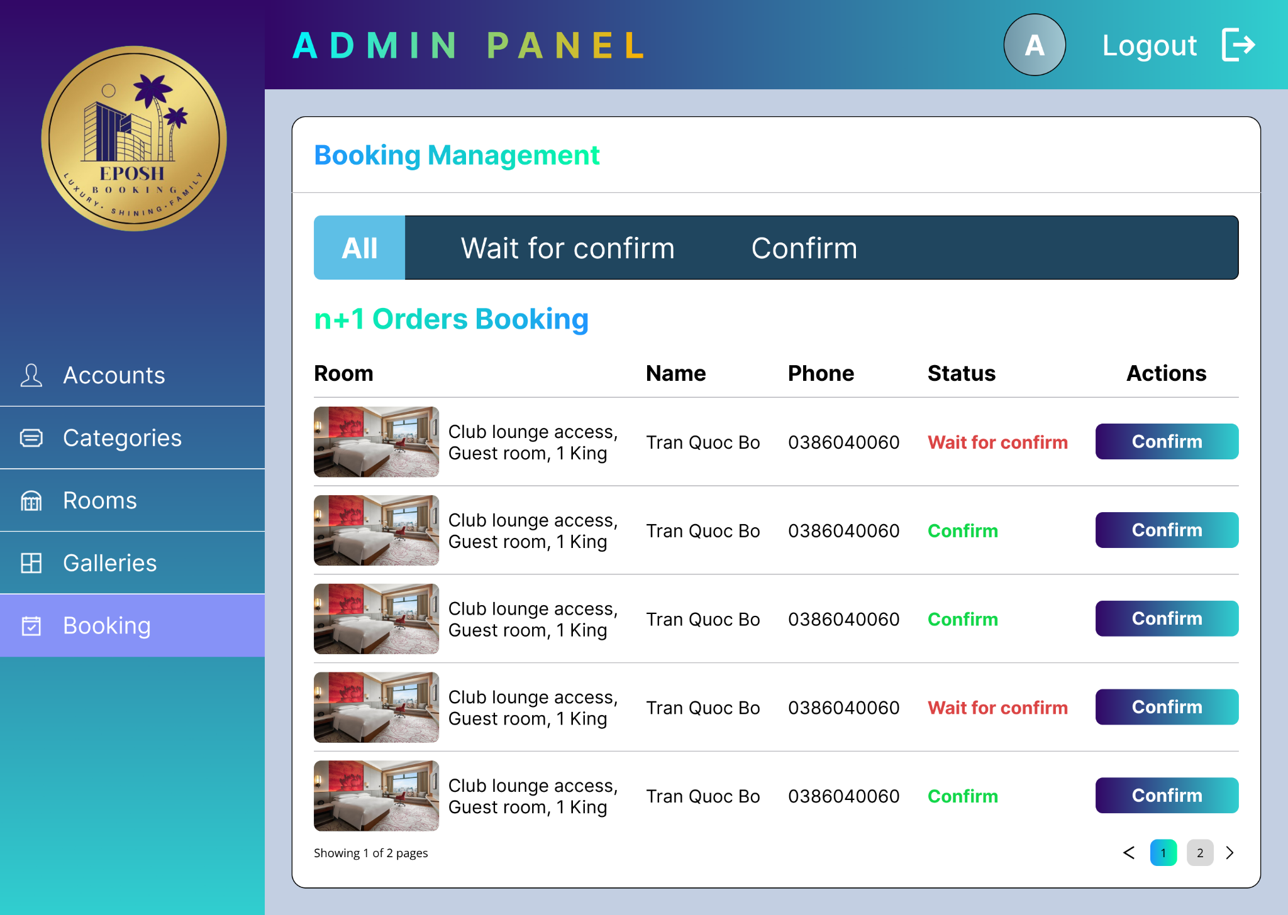

**Figure 3.5:** Booking Management Page

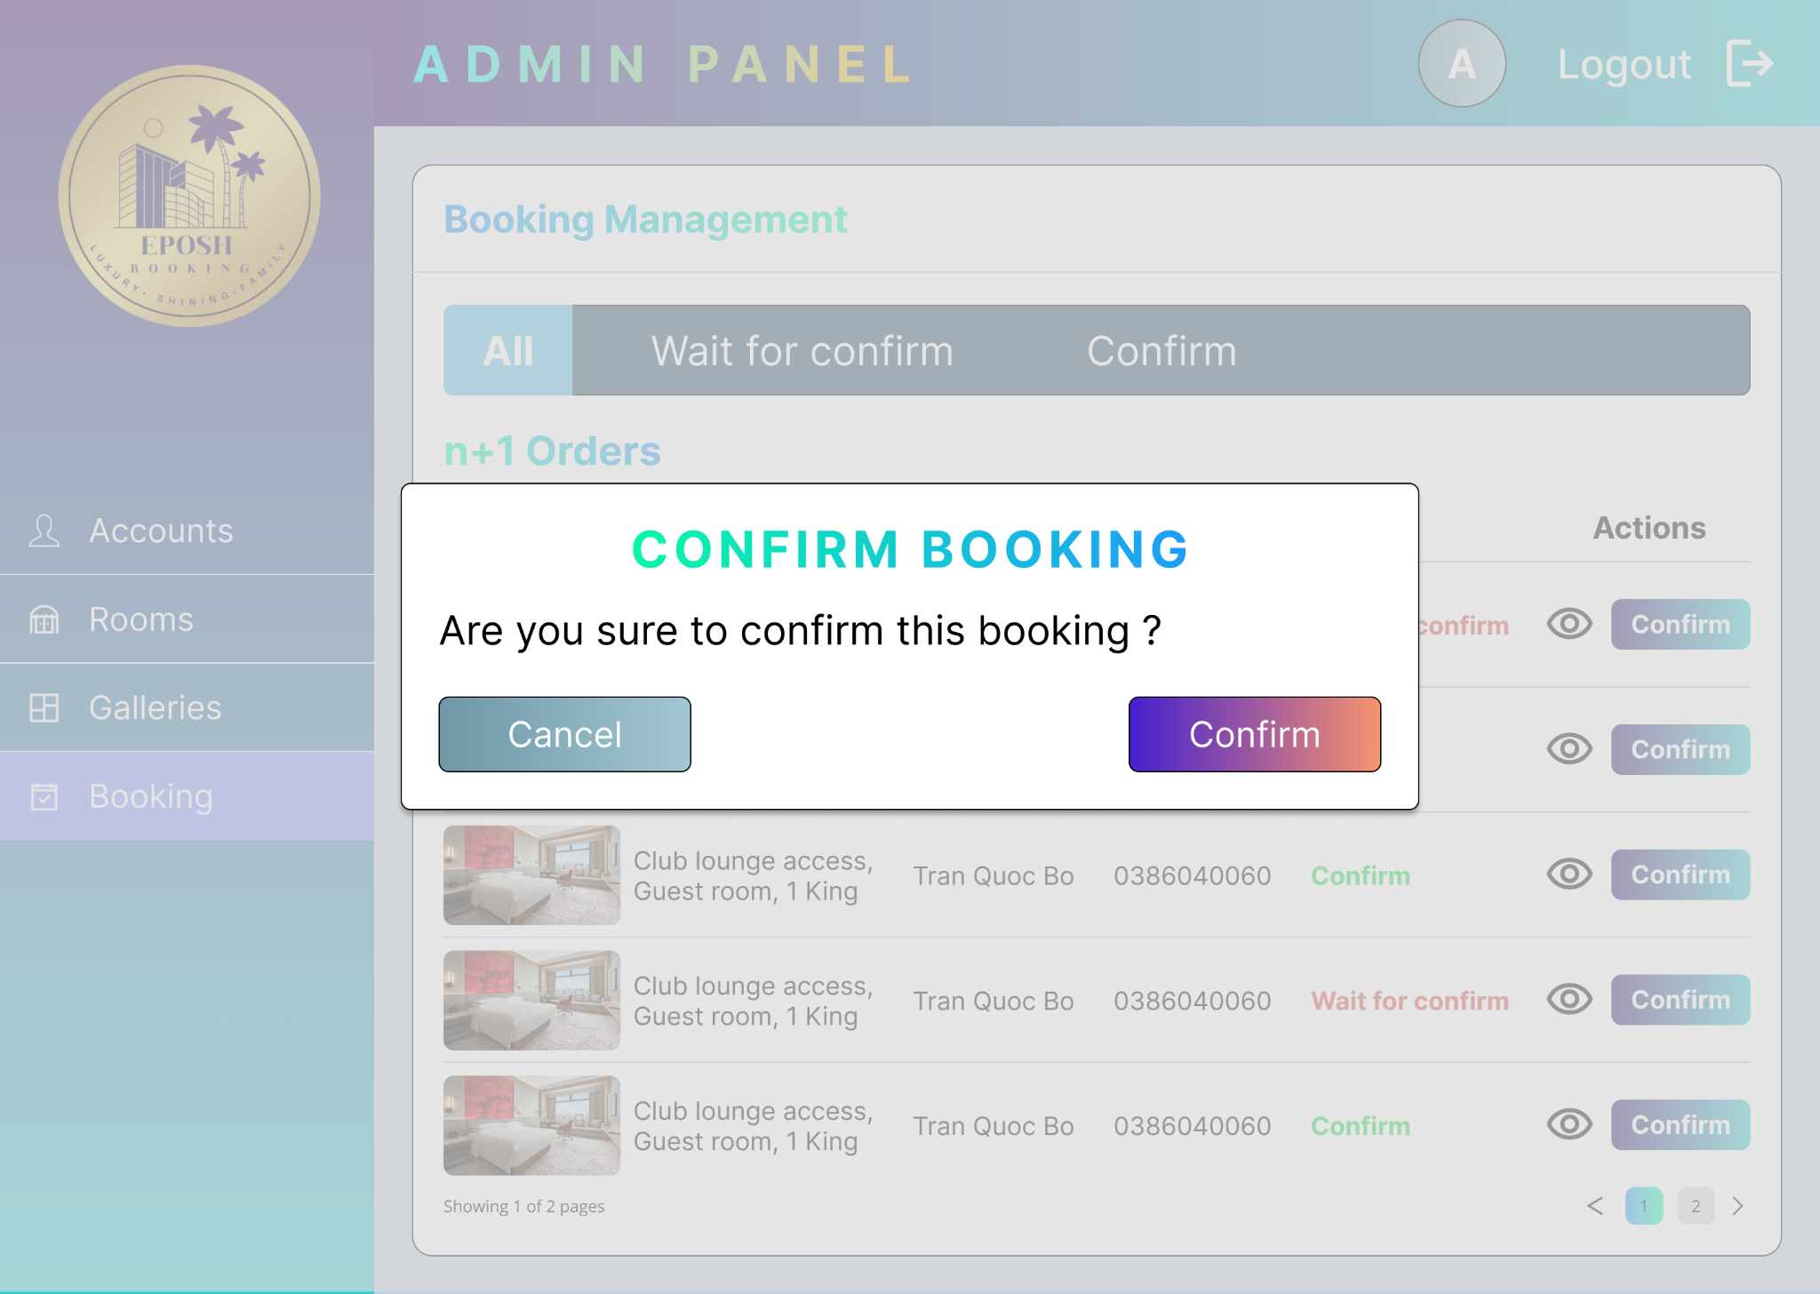

**Figure 3.5.1:** Confirm Booking Modal

# **Task assignment table**

|  |  |  |  |
| --- | --- | --- | --- |
| **Member** | **Task** | **Completion rate** | **Contribution rate** |
| Trần Quốc Bảo | * Login * Register * Send mail * Update new password * Add room * Update room * Search room with category * Get all booking * Create booking * Get booking by account id * Confirm booking * MD5 password * Create token * Get info’s user from token * Combination token * Group management | 100% | 20% |
| Đoàn Minh Hiếu | * UI/UX role Admin * Login Page * Register Page | 100% | 20% |
| Nguyễn Tiến Đạt | * UI/UX role User * Forgot password Page | 100% | 20% |
| Nguyễn Văn Hiếu | * Get all category * Add category * Update category * Delete category * Change password * Search account by full name * Delete room | 100% | 20% |
| Nguyễn Thanh Phong | * Get all image from table gallery * Add image to gallery * Delete image to gallery * Get profile by account id * Update profile * Get all room * Get room by id | 100% | 20% |